PROST Upgrade: Model and Estimation Methodology
June 2026

Introduction
This note describes the methodology of the PROST Upgrade, the individual-record version of the World Bank’s pension projection model. For two decades PROST projected pensions based on cohort averages, with groups of workers treated as homogeneous. That approach needs less data, but it cannot represent the diversity of real contribution histories, and it makes modeling of reform difficult because it requires the user to make explicit assumptions about changes in cohort behavior . The PROST upgrade replaces the cohorts with individual records: each worker now carries their own age, gender, wage, contribution history, account balance, and length of service, which are projected forward one person at a time. Two workers with the same wage but different contribution patterns - one with long stable spells, the other contributing on and off - will accumulate length of service differently, reach benefit eligibility at different times, and retire with different account balances. The PROST upgrade tracks each of them in their own right.
A cohort model applies each contribution and benefit rule to a group average and is accurate only to the extent that these rules are linear. For example, the average benefit of two workers with length of service of 10 and 30 years, should be the same as a benefit for a worker with 20 years of service, which rarely is the case. Working from individual records removes this implicit requirement for linearity: every rule is applied to a worker’s own wage, contribution history, and balance, so the dispersion within a group, which is what decides who reaches eligibility and who falls short, is carried explicitly rather than based on user assumptions. Following diverse individuals also lets the projection respond to benefit eligibility reform automatically rather than based on tedious and haphazard user assumptions: each worker’s moves into and out of contribution state are tracked in the context of their 'distance’ to benefit eligibility, so a reform that shifts those eligibility thresholds shifts the behavior of the workers it affects automatically, greatly simplifying user experience.
The estimation methodology has two parts. First, a pre-processing module of six steps prepares the inputs for the simulation engine. This part might be different for different data environments. For example, a database of active contributors would be prepared for the simulation engine differently than a database of affiliated workers that includes dormant members. Second, the simulation engine takes records of individual workers and advances them forward over the projection horizon, with the same calculation engine using the same methodology in every application.
Most of this note is focused on describing the simulation engine, and especially the two monthly rates that determine whether a worker contributes next month.
Those two rates are the probability of leaving the contribution state, denoted T₁, and the probability of returning to it, denoted T₂. Between them, the two rates describe how often a worker contributes and whether those contributions come in long stable spells or in frequent stops and starts, which a single average contribution density of a cohort does not show. This difference matters, because an economy where contribution spells are long would generate more ‘winners’ with long contribution histories counterbalancing the cohort average with more ‘loosers’ who find it harder to reenter the job market and complete benefit eligibility requirements. .
Data environments of World Bank client countries differ greatly, creating a formidable challenge for building a pre-processing module. On one end of a spectrum, a country may have a complete monthly history of every worker, on the other only a few published aggregates may be available, and the required inputs for calculation engine must be built nevertheless. When the data environment is especially restrictive, assuming underlying diversity of contributor histories that do not contradict the observed aggregate data is still possible in principle but may not be advisable. In those instances, many of the model outputs, like for example the cost of minimum pension guarantee, would be offering users a false confidence that is not based in fact. The proposed hard cutoff on the data availability scale beyond which the use of upgraded PROST should not be advisable is the same as for the older PROST version – beyond age and gender-specific aggregates, at least some real data on contributor and pensioner income distribution, as well as on the size of dormant affiliate population or average career length has to be available. A more comfortable data availability threshold is the point at which individual income records are available at least at two points in time (e.g. two consecutive years), which allows to avoid creation of synthetic individuals around the observed average and offers a firmer basis on which to calculate rather than assume transition rates T1 and T2. To summarize, the inputs required for the calculation engine are estimated at pre-processing stage by different methods in different data environments. However, once estimated, they all feed the same engine, and the engine uses them in exactly the same way. .
The pre-processing step prepares a fixed set of inputs for the calculation engine to use throughout the whole simulation horizon. These inputs are not re-evaluated after each projection step year by year and consist of: the base-year population of active and inactive affiliates; the register of current beneficiaries; the two transition rates T₁ and T₂ derived from affiliate data; the wage distribution by age, sex and decile; the age and gender-specific affiliation rates that bring in new entrants; and the retirement, disability, and survivor pension generation rates (the last two have not yet been added to the model at this stage).
Once the pre-processing module provides the inputs to the calculation engine, the projection stage begins. The calculation engine advances one year at a time, applying a fixed sequence of operations. It first determines the parameters in force for that particular year, including the contribution rates and benefit eligibility and pension calculation rules. It then adds a cohort of first-time entrants, ages the surviving population by one year, applies mortality rates, resolves the monthly moves into and out of contribution, and moves eligible affiliates into retirement, computing the pension for each. For a worker active at the start of the year, each month their next contribution state is decided by their exit probability rate T_{1.} An inactive affiliate may resume contributions next month based on their re-entry probability rate T_{2.} For those who qualify for retirement, pension is computed according to the rules of the pension plan of a worker (pension eligibility does not need to necessitate the retirement, but this flexibility will be added to the model at later stage). Alongside these rules, the projection follows a macroeconomic and labor-market scenario the user sets: a path of economy-wide wage growth, an unemployment turnover rate, a trajectory for the employment rate, and the share of affiliates who contribute. These govern how fast wages grow and how many workers move into and out of contribution state each year. This same loop repeats over the simulation horizon, up to eighty years or beyond if needed.
The model treats the defined-benefit and defined-contribution schemes as two pillars that coexist within a single projection, both active at the same time, each worker belonging to one of them. . This is a different arrangement from the original PROST, in which the defined-benefit scheme was the default and a defined-contribution pillar was introduced only as a reform, modeled as the transition from one to the other. For the present the two are treated as concurrent structures rather than as the before and after of a structural switch: a worker remains a defined-benefit or a defined-contribution member throughout, and the projection carries both populations forward in parallel. Allowing for a switch between DB and DC plans as well as simultaneous participation in both pillars is a feature to be added in the future. Another feature to be added is a possibility of a simultaneous participation in several DB and DC pillars at the same time. For example, a worker can participate in a DB civil servant pillar and a private DB pillar, possibly as a dormant contributor in one of them, eventually retiring from both pillars or transferring accumulated rights from one pillar to another. Similarly, simultaneous participation in notional and funded DC plans would be possible.

The note is ordered so that nothing is used before it is built: the data environments first, then each input the pipeline produces, and the projection engine that consumes them last. Throughout, the rich environment of full monthly histories is documented in full, with Mexico as the pilot, and the methods for scarcer data are given alongside. The remaining sections set out how each of these inputs is produced. Which of them a country can estimate, and by what method, is determined by the data available, which is the subject of the next section.

2 The pre-processing module for different data environments
The pre-processing module produces six inputs for the calculation engine, but does so differently depending on the data environment, as shown in Table 1. So far, the model has been tested for four different levels of data availability:
- A rich environment has a full longitudinal panel of individual contribution histories at a monthly frequency, so that each worker’s active and inactive months are observed directly.
- A low environment has the same kind of monthly records but only for a short or interrupted period, so that some transitions are seen but full contribution and inactivity spells cannot always be reconstructed.
- A very-low environment has only a single observation per year for each worker, specifying the number of months contributed, so that partial-year contribution reveals that a transition between the active and inactive contribution state occurred, but without revealing the actual monthly sequence. Affiliates who do not contribute in that year are not recorded in the database.
- An extremely-low environment has only aggregate contribution data for each worker, in effect the contribution density, with no within-year detail. Only age and gender-specific aggregate number of beneficiaries is available.
In the rich environment, individual transitions are observed directly; in the other three cases of limited data - low, very low, and extremely low - they must be inferred. These data availability differences matter most for the transition rates T1 and T2, where each of the four environments calls for a different estimation route; for the simpler inputs the distinction is largely between what is observed and what must be synthesized. Generally, reporting frequency would be monthly for administrative records and annual for the surveys, on which lower level data environments would mostly rely on. The user declares the data structure at the outset, and each pre-processing step carries a method for the rich case with a fallback option as the data thin. The data quality in a given country will usually vary from these four levels, and the pre-processing steps would be adjusted accordingly. The subsections that follow describe how each input (step of the pre-processing module) is treated depending on data availability and how it is eventually used by the calculation engine.
Table 1. How each of the six inputs is produced in each of the four data environments.
Step (input produced) | Rich | Low | Very low | Extremely low
1. Wage growth profiles | from the panel | from the panel | borrowed, anchored | borrowed, anchored
2. Base-year affiliate population | observed | observed | observed | synthesized
3. Beneficiary database | observed | observed | observed | synthesized
4. Affiliation rates | first month observed | estimated from affiliation length | estimated from affiliation length | estimated, reweighted for attrition
5. Transition rates T₁, T₂ (new actives, new inactives) | maximum likelihood on transitions | maximum likelihood, spell proxied | moment + identity, GLM-smoothed | identity + synthesis
6. Retirement, disability, survivor | from beneficiary data | defaults | defaults | defaults

3 The wage model (step 1)
The simulation engine uses wage data supplied by pre-processing module in three ways: (1)each worker is assigned a wage decile, which is a covariate with T₁ and T₂; (2) the wage growth of each worker over the projection period is adjusted in accordance with the seniority factor; and (3) average wage is anchored to a user-specified path of economy-wide nominal wage growth. The decile is assigned based on individual’s relative position compared to average wage, the seniority factor is estimated by simple regression; and the anchoring is applied each year in the projection loop.

Relative wage and decile assignment
Wages are handled throughout as monthly amounts.

For every worker-month a relative wage is computed, the monthly individual wage divided by the economy-wide average monthly wage,
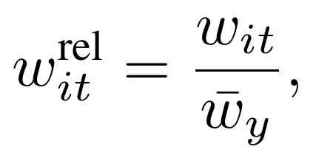
with worker’s relative decile determined by the last time they worked, with relative positions of workers comparable across time. Thismethod of comparing workers’ relative positions across time is preferable to employing inflation-adjusted nominal wage comparisons that are influenced by inflation and by shifts in the wage distribution. . All workers are ranked on the relative wage of their last contributing month and divided into ten equal groups, labeled 1 (lowest) to 10 (highest). The ranking is single, not stratified by age or gender. Each worker’s decile is carried backward through their entire history. . Carrying the decile denomination back is a substantive assumption: it holds that a worker’s most recent decile is their true decile. Because that decile then enters the estimation of the transition rates T1 and T2, it is further assumed that a worker’s transition behavior reflects this most recent decile rather than the one they held at the time of each transition. Furthermore, fixing the decile denomination from the latest year and holding it across the whole history treats a worker’s standing in the wage distribution as a structural trait rather than something re-drawn each period. Similarly, moving forward, once an inactive worker returns to contribution the same decile denomination, and T1 and T2 rates linked to it, are restored to the worker

The seniority factor
The seniority factor is the age, gender, and decile specific multiplier of economy wide average wage growth that applies to a specific cohort. For each cohort and year, the mean wage is computed, and year-over-year growth is taken for the cohort and for the economy as a whole,
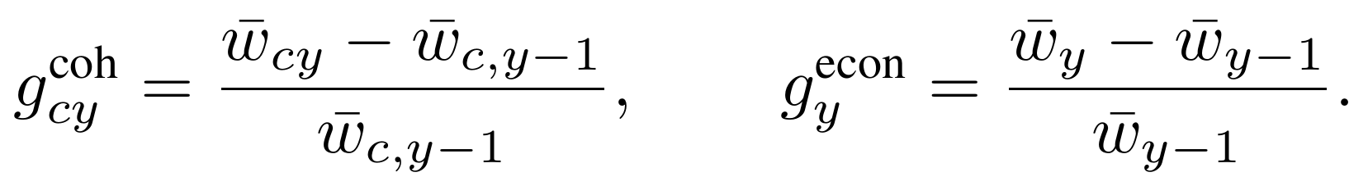
The seniority factor is the ratio of the two, the cohort’s growth relative to the economy’s,
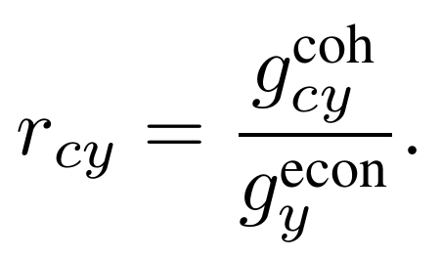
Before estimation, workers who already qualify for a pension in period t are removed, to avoid the situation where they are part of the cohort in period t-1 but not in period t. Observations more than three standard deviations from the mean of the relative-growth distribution are also trimmed. The seniority factor is then smoothed by an ordinary least squares regression of relative growth on the full interaction of wage decile, gender, and age, each entered as indicators,
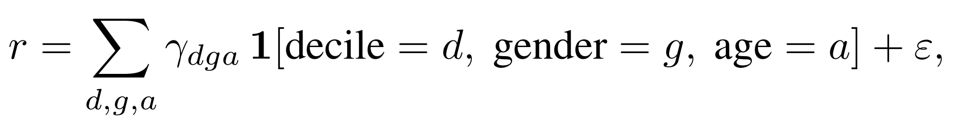
and the fitted r̂(d,g,a) is saved, giving a value for every cell, including those thinly observed in the raw data.

Missing wage data and wage growth anchoring
Wage decile and seniority factor described above ideally are calculated from a full panel of individual wage histories, the kind that exists only in the rich data environment. Even then, the possibility of inconsistent data and a drift arising from multitude of detailed wage growth calculations should be accounted for.. This section sets out how the wage-related inputs for the calculation engine are obtained when the panel is short or missing and how the estimated are anchored, so that the engine has, in every environment, a robust wage and wage growth for each worker.
As the data thin, the parts that can no longer be read from observed wages are filled in or borrowed, and two devices do that work in every data environment: a regression that supplies a missing wage, and the user-specified path of economy-wide wage growth, which pins the average of age, gender, and decile specific wage growth rates.
The first device is a regression that supplies a wage wherever one is missing, for example for inactive affiliates without a record of prior wage, predicting it from the worker’s contribution density, gender, and age,
Here w-hat is the predicted monthly wage; the coefficients (theta-0 through theta-4) are estimated once from workers whose wages are observed; CD is the contribution density, the proportion of months the worker has contributed since their affiliation; female is one for women and zero for men; and age enters both on its own and squared, so the fitted profile can rise and then flatten over a career. A Heckman selection model could be used to correct for biases that arise due to structural differences between contributors and non-contributors. This method can be applied if there is adequate data for specifying a selection equation that distinguishes between contributors and non-contributors.
The second device is the user specified path of economy-wide wage growth. At the end of each projected year, every wage is multiplied by one common factor, chosen so that the average wage in the simulated population grows at exactly the rate the user specified, which constitutes the anchoring rescaling of wages. The level of wages is therefore always pinned to the user-specified path. With these two devices in hand, the wage model is built environment by environment as follows.
- Rich: a full panel of wages. All three parts are estimated directly. The decile is set by ranking affiliates, active and inactive, on their relative wage and dividing the ranked list into ten equal groups. The seniority factor is estimated from the panel by tracking, for each birth-year, gender, and decile, how fast wages grow from one year to the next, then dividing that rate by how fast the whole economy’s wages grow in the same year; that division strips out inflation and general wage rises and leaves only the part of growth that comes from aging and accumulated work experience. In the projection, each worker’s wage grows by the user-specified economy-wide growth adjusted by the seniority factor, after anchoring rescaling to seniority factors is applied. An inactive worker has no observed wage for the months they do not contribute, so one is calculated from the wages recorded while they were active.
- Low: a short or interrupted panel. In this case, the observed wages are used just as in the rich case, and the seniority factor can still be estimated provided the records span at least two years, since the factor is built from the change in wages between consecutive years and so needs two years to be calculated for each person at least once. What is new is filling the holes a short panel leaves. A missing month is set first to the worker’s own most recent observed wage, carried forward unchanged,
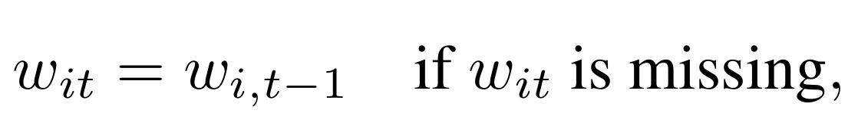
where w-it is the wage of worker i in month t; and if a worker has no observed wage anywhere, the regression above supplies one from their density, gender, and age. Missing wages for inactive workers are filled the same way.
- Very low: a single year of wages. We assume that every country has at least two years of data, or that average wage growth can be taken from another source. Either way, the very-low and extremely-low environments are not currently implemented in the pre-processing. As a proposed refinement, the agregate seniority wage profile would be used instead of individual observed wage growth rates, just as implemented in current PROST model, The estimation would compare wages of current cohort aged a and another cohort aged a-1, instead of comparing wages of the same cohort across two time periods. Using the agregate seniority profile would not put the average wage level at risk: the anchoring would still force simulated economy-wide growth to equal the user-specified path, so the agregate profile would decide only the relative timing of raises over a career, not how high wages finally reach.
- Extremely low: no individual wages at all. The wage data is only supplied in aggregate for the age and gender specific cohort and the agregate wage distribution is given, just as in current PROST input file requirements, so there are no individual wages either to rank or to grow. Each worker is instead given a wage drawn to reproduce the aggregate statistics that do exist.The anchoring once again fixes the level. From the moment they are assigned, these wages are treated exactly like observed ones: they fix each worker’s decile, feed into the contribution transition rates, and rise along the borrowed life-cycle profile year by year. As with current PROST approach, this algorithm would only be able to give unreliable statistics related to wage distribution, including the statistics on minimum pension guarantee.
Of these routes, the regression, the carry-forward of the last observed wage, and the economy-wide anchoring are implemented in the current code; the agregated-and-calibrated seniority profile is a planned extension. Until it is in place, the very-low and extremely-low environments rely on the anchoring and the regression alone, so the level of average wage is always correct and no wage is ever missing.

4 The base-year affiliate population (step 2)
The projection starts from a base-year population of individual records: the engine will carry every affiliate forward, each with their age, gender, wage decile, contribution history, and accrued rights.
Where the full longitudinal microdata exist, the base year is taken as the latest year observed. When the longitudinal data are too large to use in full, we use a weighted sample of them, drawn to reproduce the aggregate totals, with each record carrying a weight. Each worker’s age and length of affiliation is carried in the data. Contribution spells, defined as runs of consecutive months in the same contribution status, are identified by the points where the contribution status changes, and the length of the current spell is measured in the count of months in it. The length of contribution spells are later used to derive contribution transition rates.
The affiliate population is assembled as follows in each of the four data environments.
- Rich and low environments. Individual microdata are available, so the observed records directly translate into the base-year affiliate population. Where the datasets are too large to use in full, a weighted sample of them is drawn to reproduce the aggregate totals.
- Very-low environment (only current contributors are recorded). The inactive affiliates are missing and must be rebuilt. An inactive affiliate is someone who joined the system and holds accrued rights but has stopped contributing, so does not appear among the current contributors; left out, the base-year record population would understate the affiliated stock and overstate contribution density. The share of the affiliated population that is inactive is estimated from another source, and the inactive affiliates are added to the database at the implied size. The estimate of affiliate population could come, for example, from survey data or from the ratio of the sizes of retiring and contributing cohorts, adjusted for mortality.
- Extremely-low environment (only age and gender-specific aggregate tables exist for contributors and beneficiaries). This scenario that mirrors current PROST data requirements, like the very-low one before, is not yet implemented in the pre-processing module. A synthetic population would be constructed whose cell-level statistics reproduce the target aggregates. This is the same base-year record construction exercise that was already mentioned when describing the extremely-low case scenario for wage model. The algorithm would construct the record database of headcounts, wages, and contribution status at the same time in four steps:
- Assemble a pool. Records are gathered from whatever base-year microdata are available, each reduced to the few facts the aggregates constrain: whether they ever contributed, their mean wage while contributing, and their end-of-year account balance.
- Match the headcount. Each age-and-gender cell is brought to its target size: the records in the cell are shuffled and sampled down where the target is smaller than the number available, cloned by replication where it is larger, and trimmed of any rounding surplus, so the cell ends with exactly the number of individuals the aggregate prescribes.
- Rescale the money. Each wage and balance is multiplied by the cell-level ratio of the target mean to the sample mean, so the cell mean matches the target while the within-cell spread is preserved, and account balances follow the same rule, each scaled by the ratio of its own target and sample mean. For a cell c with n-c records drawn into it, the sample mean is the plain average wage of those records, and the target mean is the average the aggregates report for that cell, which is not computed from the draw; scaling each wage by the ratio of the two leaves the rescaled cell mean equal to its target while the relative spread is unchanged,
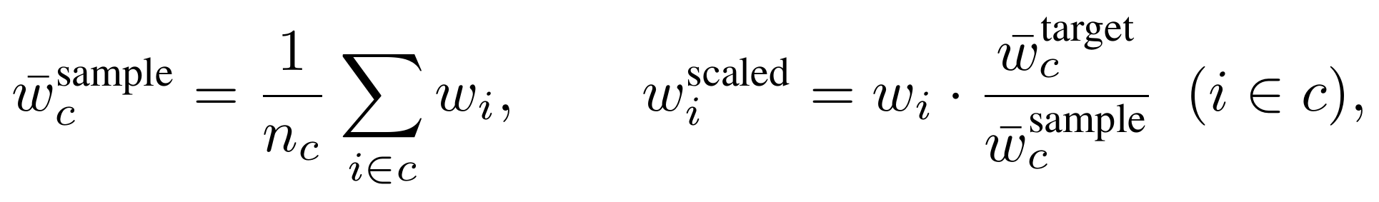
- Assign status. Within each cell the individuals are ranked at random and contributor status and financing type are assigned to meet the aggregate contributor counts: the first block is set as contributors of one financing type, the next as contributors of the other, until both totals are met, and the remainder left as non-contributors carrying a financing label drawn at the same mix. A record promoted to contributor is then made to contribute through the year at its rescaled wage, and one demoted is set inactive, so the monthly histories stay consistent with the status assigned.
Two further details complete the construction. Cells the aggregates require but the available records lack, typically the oldest ages or the youngest women, are filled by borrowing the individuals of the nearest available age within the same gender, and, only where a gender has no records at all, of the nearest age in the other gender, the borrowed records relabeled to the target age. A verification step then recomputes the synthetic aggregates and reports their deviation from the targets, so the match can be checked rather than assumed.

5 The beneficiary database (step 3)
The beneficiary database contains the records of current pensioners, included in the projection so that the benefits already in payment are carried forward and indexed alongside the new pensioners the engine generates.
Each pensioner carries an age, a gender, the year the pension began, and a monthly benefit. The classifying step is the placement of each pension along two independent dimensions. The first is financing: a pension is either defined-benefit, paid based on a formula incorporating years of service and insured wage history, or defined-contribution, paid as the annuitized draw-down of an accumulated account. The second is kind: a pension is either old-age, disability, or survivor. The two dimensions are orthogonal, so together they generate six mutually exclusive categories, the three kinds under each financing type. The raw register identifies each pension with a single code; that code is decomposed into the two dimensions, so that a defined-benefit old-age pension and a defined-contribution old-age pension, identical in kind but different in financing, are held apart, as are an old-age and a survivor pensions sharing the same financing.
The two dimensions are read by different parts of the model. The financing dimension informs the benefit treatment: a defined-benefit pension already in payment is carried forward by the engine’s revaluation rule, whereas a defined-contribution pension is the annuity value of the account balance at retirement, so the engine must know which it is to index it correctly. Old-age pensioners enter at the retirement rate, disability pensioners at the disability rate, and survivors at the survivor rate (Section 8). A pension misfiled on either dimension would be indexed by the wrong rule or charged against the wrong budget.
Records whose type code cannot be matched to one of the six categories are currently dropped: they are the ones absent from the aggregate headcounts supplied separately, so removing them aligns the database totals with those controls instead of carrying caseload the aggregates do not recognize.
The beneficiary database is taken as given wherever it exists or synthasized when only aggregates are available
- Rich, low, and very-low environments. A pensioner register, which almost always exists, is used directly, with no estimation.
- Extremely-low environment. No register is available, so the database is synthesized from aggregate counts by age, gender, and pension type, in the same way as the base-year population of affiliates.

6 Affiliation rates and new affiliates (step 4)
New affiliates are workers who enter the system for the first time during the projection period, distinct from new actives and from the base-year affiliate population. Their number is set by an affiliation rate. For each combination of age, gender, and year, the rate is the count of workers observed entering the system (their first contributory month) divided by the corresponding population, averaged over several recent years. The default is set to ten last years, for stability, but this number can revised by the user.
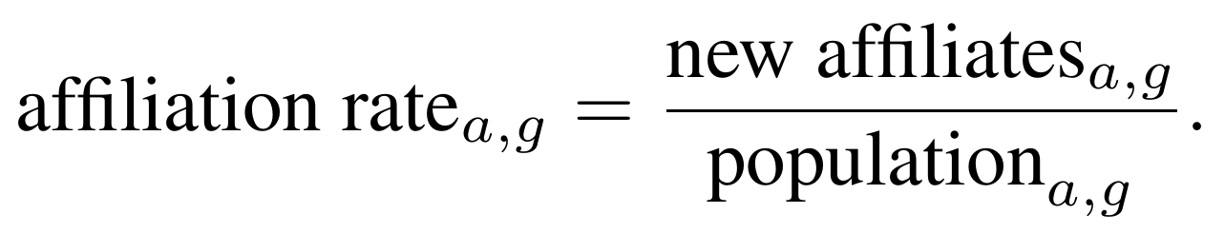
By default, the population used in the denominator is taken from the United Nations projections, which reports it in thousands, so the implemented denominator carries a further factor of one thousand, here and wherever a rate is expressed per head of this population. Any population input may be used in place of the default, provided it follows the same format, with the same variable names and counts reported in thousands.
Across the data environments. The denominator is the same in every case: the United Nations population, with entries averaged over the most recent ten years and the earliest year dropped, since a young system overstates entry. What changes from one environment to the next is only how the numerator is obtained, the count of first entries that appears as new affiliates in cell (a, g) in the rate above. It is the same quantity in every environment; only the route to it differs, so each case below is just a different way of getting the same new affiliates count.
- Rich environment (the full panel is available). A first entry is read off directly as the worker’s first contributory month, the month in which length of service and length of affiliation are both equal to one, so new affiliates in the cell is simply the observed count of these first months.
- Low and very-low environments (the first month is not observed). The year and age of entry are reconstructed by counting the affiliation months back from the observation date. Writing loa for the length of affiliation, the number of months since the worker first joined,
and the reconstructed entries are counted by age and gender, which gives new affiliates for each cell.
- Extremely-low environment (only an aggregate per worker remains). The same reconstruction is applied, but the data now retain only workers who are still active, so those who entered and later stopped contributing are missing and the count of first entries comes out too low. That count is the numerator of the affiliation rate, so left uncorrected the rate would be understated and the projection would generate too few new affiliates. To adjust for this, each surviving worker is counted as more than one: they stand in for the whole group that entered with them, those still active and those who have since dropped out, so the same numerator the other environments obtain by a head count, new affiliates in the cell, is here obtained by adding up 1 / p_active over the surviving workers,
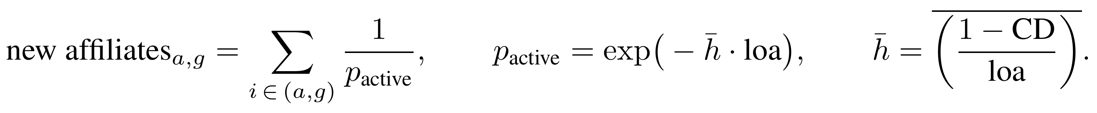
The three quantities in this expression are the survival probability p_active, the exit rate h-bar, and the contribution density CD:
- p_active is the probability that a worker who joined loa months ago is still contributing today. In the sum above each surviving worker is counted not as one but as 1 / p_active, so if half of an entry cohort has since left, then p_active is 0.5 and each worker still observed counts for two.
- h-bar is the average monthly rate at which workers stop contributing, taken within age and gender. It is read off the contribution density CD, the fraction of months the worker has actually contributed: the term (1 minus CD) divided by loa is the share of non-contributory months per month of affiliation, a simple estimate of that monthly exit rate, which is then averaged over workers of the same age and gender.
- the exponential p_active = exp(minus h-bar times loa) is the standard survival form: at a constant exit rate the chance of staying active for loa months falls off exponentially, so longer-affiliated cohorts have lost more members, and each of their survivors counts for more because 1 / p_active is then larger.
With the count built up this way, the affiliation rate is formed exactly as in the other environments, the difference being only that its numerator has been corrected for the affiliates the data no longer show; once obtained, the rate is used the same way whatever environment produced it.
In the projection this rate generates the new affiliates each year, multiplied by the projected population to give a count that is realized as individual records and carried forward like any other worker; how each new record is initialized, the decile and starting wage it is given and the covariate values it begins from, is set out with the engine’s new-affiliate step.

7 Estimating T₁ and T₂: the contribution model (step 5)
The transition rates, T₁ and T_{2,} are estimated once from past data, and the projection engine then applies them month by month to every worker, to draw who stops contributing and who resumes. They are estimated by different methods in different data environments, but they are the same two quantities everywhere, and the single engine that uses them is the same everywhere.

7.1 Why contribution density is not sufficient
The most natural summary of a person’s contribution history is their contribution density, the fraction of observed periods in which they contributed,
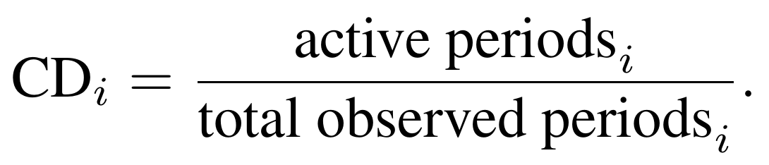
Contribution density is intuitive and widely used, but it is not sufficient to model future contribution behavior: the same density can arise from very different underlying patterns, and those patterns have different implications for pension outcomes.
Consider two workers, both with a density of 0.42. The first contributes in long, stable spells, eighteen to twenty-four months active, then a year or so inactive, then another long spell, for an average active spell of about twenty months. The second contributes and stops almost every other month, for an average active spell of about two months. Both reach the same density, but they are fundamentally different: the first holds long stable spells, the second churns constantly. A model that draws contribution status independently each period with probability equal to the density treats the two identically, because it has no memory of the previous period and cannot tell a long stable spell from rapid churning.
Table 2 shows two male affiliates from the Mexican records with almost the same density and entirely different spell structures.
Table 2. Two male affiliates with the same contribution density and different spell structures.
Characteristic | Worker A (id 446841) | Worker B (id 404689)
Year of birth | 1975 | 1978
Total observed periods | 282 months | 280 months
Active periods | 118 months | 118 months
Contribution density | 0.418 | 0.421
Length of service | 118 months | 118 months
T₁ (active → inactive) | 0.042 | 0.161
T₂ (inactive → active) | 0.030 | 0.117
Average active spell | 23.6 months | 6.2 months
Average inactive spell | 32.8 months | 8.5 months
Number of active spells | 5 | 19
Number of inactive spells | 5 | 19
Over their first sixty months the two sequences make the difference visible at a glance (A active, I inactive):
Worker A: AAAAAAAAAAAAAAAAAAAAAAAAAAAAAAAAAAAAAAAAAAAA IIII AAAAAAAAAAAA
Worker B: AAAAAA IIIIIIIIIIII AAAAAAAA IIII AAAA II AA II IIAA II AAAAAA II
Both workers arrive at the base year with the same length of service, 118 months, and the same density, 0.42, and a model that uses the density directly cannot tell them apart. Yet their exit rate T₁ differs by a factor of almost four (0.042 against 0.161) and their re-entry rate T₂ by a factor of almost five (0.030 against 0.117): the first worker’s long spells make him very unlikely to leave the active state in any given month, while the second worker’s churning means he changes state every six to eight months throughout his career.
Going forward, the second worker continues to accumulate service in small fragments. If both maintain the same average density and have the same time left until retirement, they reach the same expected length of service, but the fragmented path produces a far wider range of possible outcomes, which makes the second worker more likely to fall short of the required years of contribution just as he approaches the eligibility threshold.
The model is therefore built on the transition rates T₁ and T₂ rather than on the density: the two rates encode the persistence of the active and inactive states, the spell structure that the density discards, from which length of service, eligibility, and benefits follow. The rates also tie directly to the projection’s economic assumptions. Turnover and the growth of the employment rate act directly on them, but reach contribution density only indirectly, through job transitions, so building the model on the rates allows a user to change these assumptions and observe their effect on density, which modeling density directly would not allow. They also operate within a single year, whereas density accumulates over time, so relying on in-year transitions aligns more closely with the projection’s year-by-year structure.

7.2 The model: a two-state transition
In each month a worker is either active or inactive, and the two rates are
the probability of leaving the active state and the probability of returning to it. Here T₁ is the out-transition (active to inactive) and T₂ the in-transition (inactive to active). Each is modeled in discrete time with the complementary log-log (cloglog) link,
which maps a linear index η to a probability in (0,1), and is the discrete-time form of a process with a constant underlying rate within the month. A benefit of the cloglog link is that its coefficients, once exponentiated, can be interpreted as hazard ratios; it is the discrete-time counterpart of the continuous-time Cox proportional hazards model.
The exit rate is specified, on the months in which the worker is active, by
and the re-entry rate, on the worker-months in which the worker is inactive, by the same terms plus the worker’s accumulated contribution density,
Here the contribution density CD = los/loa is the same density introduced in Section 7.1, the share of contributory months, written now as length of service over length of affiliation. The term f(s,d) is the interaction of spell length with wage decile, which lets the dependence on elapsed duration differ across the wage distribution, and it is the device through which the rates carry the spell structure that motivated them. The covariates are
where los is length of service, loa is length of affiliation, MCP the minimum contributory period in months, R the retirement age, and 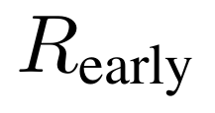 the earliest retirement age. The two indicators encode the pension rules: 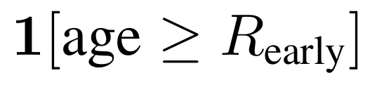 marks workers who have reached the earliest retirement age, and nohope marks workers whose remaining contribution requirement has overtaken the time left until retirement age.
This single specification is what the model uses in every data environment, not the richest alone: the equations above give the functional form of the rates everywhere. What changes is how that form is connected to data. Where individual transitions are observed, in a rich or a short panel, it is fit to them directly by maximum likelihood. Where they are not, in a single cross-section or in aggregates, the rates are first recovered by other means and the same form is used only to smooth them across cells. So what changes as the data become scarcer is the way the coefficients are obtained, never the specification itself, and the two rates are always estimated independently of one another; the next section sets this out. The covariates losgap and nohope measure the worker’s proximity to eligibility, and the case for them in place of age alone is set out in Section 7.4.

7.3 T₁ and T₂ across data environments
How T₁ and T₂ are obtained depends entirely on the data at hand; how they are used, once obtained, does not. Figure 1 sets this out: four data environments, each with its own estimation route, all converging on the same pair of rates, which then feeds one engine.
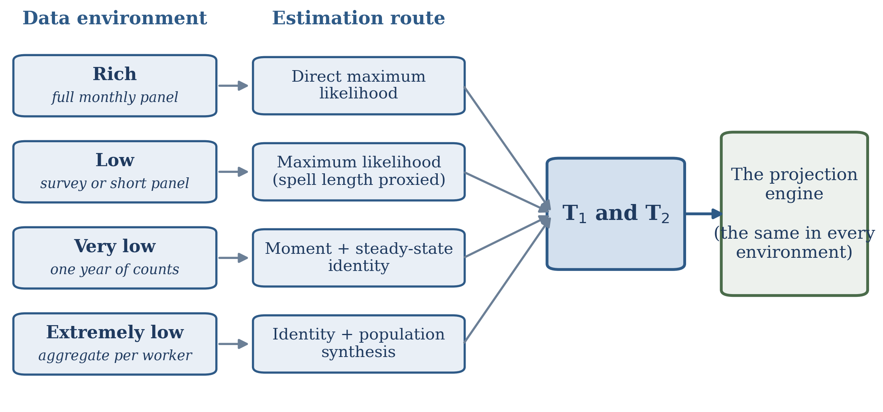
Figure 1. T₁ and T₂ are estimated by a different route in each data environment, but the routes converge on the same pair of rates, which then enters a single projection engine that is identical in every environment.
The specification of Section 7.2 is fixed; what changes is the route to its coefficients. All four routes aim at the same target, the monthly transition rates T₁ and T₂, and they differ only in how much of the underlying transition behavior the data let them see. As the data thin, the route moves from estimating the rates on observed transitions, to proxying the pieces that are missing, to recovering them from an equilibrium identity, to synthesizing the population they are computed on. In every case the coefficients are estimated once, on the historical sample, saved, and reused unchanged in the projection; the route turns on one question, whether individual transitions are observed, and then on how much else remains. (The rates are not the only input that adapts to the data; the base-year population, the beneficiary database, and the affiliation rates do too, as Section 2 sets out. They are the hardest, and these four routes are the subject of this section.)
- Rich: a full monthly panel. Every worker-month records whether the worker contributed, so the two transitions are observed directly: an active month followed by an inactive month is an exit and identifies T₁, and an inactive month followed by an active month is an entry and identifies T₂. Spell length is the true elapsed number of months in the current state. The two rates are fit by maximum likelihood under the cloglog specification of Section 7.2, cloglog(T₁) on the active worker-months and cloglog(T₂) on the inactive worker-months, with standard errors clustered by worker since each worker contributes many correlated observations; the coefficients are saved and reused in the projection by evaluating the same model at each worker’s current covariates, never re-estimated. This is the environment documented in full here, with Mexico as the pilot.
- Low: transitions observed, not always possible to reconstruct spells. A short or interrupted panel still shows the transitions, so T₁ and T₂ are estimated exactly as in the rich case. What cannot always be recovered is the elapsed spell length, since the record may not reach back to the start of the worker’s current state; it is proxied by accumulated exposure, the length of service standing in for time spent active and the gap between length of affiliation and length of service for time spent inactive,
- Very low: one year of contribution counts. The panel is gone: the data give only the number of months each worker contributed in a single year (the within-year count dens), so no transition is ever seen. The rates are recovered in four steps.
- Infer that a transition happened. A worker who contributed in some but not all twelve months must have changed state at least once during the year, whereas a full or empty year carries no such evidence,
- Form the exit rate as a moment. Within each cell c, a single decile-gender-age group, the exit rate is the count of workers who transitioned over the total months worked in the cell, the average number of exits per active month and the discrete-time counterpart of what the rich data would estimate,
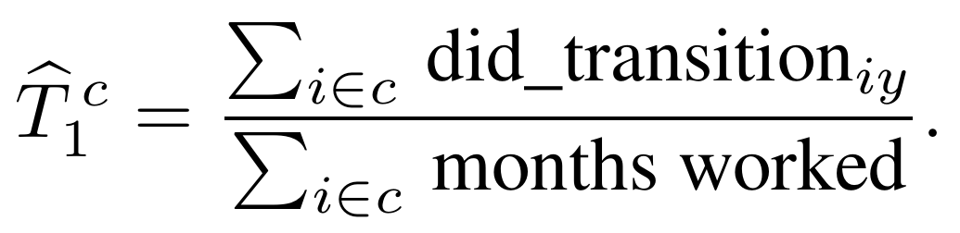
- Recover the re-entry rate from steady state. In equilibrium the flow out of activity equals the flow in, so the active stock times the exit rate equals the inactive stock times the re-entry rate; writing the active share as the contribution density CD, this gives the re-entry rate wherever the exit rate and density are known. The identity assumes the system is in steady state, which is the main approximation of the route, since where equilibrium fails the re-entry rate inherits the error,
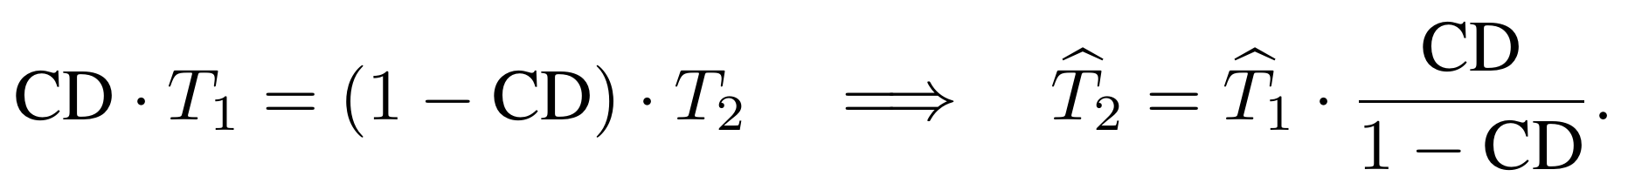
- Smooth and normalize. Both rates are smoothed onto the covariates of Section 7.2 with a binomial generalized linear model and predicted for every cell, so even thinly populated cells receive a rate. The smoothing is fit on the tails of the density distribution: the re-entry rate on workers with a density of one month or less, inactive almost all year and standing in for the currently inactive, and the exit rate on workers with eleven months or more, standing in for the currently active, which reproduces the conditioning on current state that the rich-data estimate performs automatically. The density is itself correlated with the rates, so this can bias the levels, though the covariate log(CD) absorbs part of it; the re-entry rate is then rescaled to the unit interval by dividing each cell’s value by the largest across cells, T̂₂ / max T̂₂, rather than capped at one.
- Extremely low: aggregate contribution per worker. At the limit the data are a single aggregate per worker, in effect the contribution density, with no within-year counts to form the partial-year indicator. This is the least precise of the four routes, resting entirely on the steady-state identity and a synthesized population. Two things change from the very-low route: the base-year population, having no individual records to begin from, is synthesized first from aggregate counts by age and gender (Section 4), so there is a population of records to attach rates to; and the re-entry rate is taken straight from the steady-state identity, capped at one rather than formed as a moment, after which the cloglog smoothing is applied on the density tails as before,
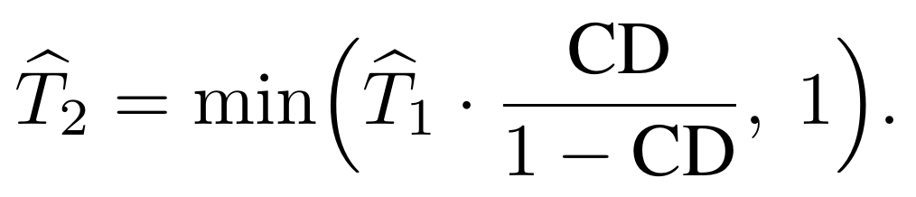
Whichever environment applies, the result is the same pair of rates, T₁ and T₂. From here on the data environment plays no further part.
However T₁ and T₂ were estimated, the single engine uses them in exactly one way, and that way is identical in every environment: each month it evaluates the saved model at every worker’s covariates, scales the two rates by the common factors so the aggregate flows match the user’s labor-market targets, and draws each worker’s move, exactly as set out with the contribution transitions in the engine. Nothing in that loop depends on the data environment. Because the rates are rescaled to the aggregate employment and turnover totals, the estimate need not pin down their levels precisely; what matters is a stable ranking across worker types, by age, wage decile, and gender, and a density concentrated near zero.

7.4 Why proximity to eligibility, not age alone
Proximity to eligibility and the contribution pull are one mechanism, not two. Proximity, the remaining distance to eligibility, is the variable; the pull, the tendency to hold on and keep contributing as that distance shrinks and eligibility becomes reachable, with its reversal into a repel once eligibility is out of reach, is the behavior that variable produces. The argument below is for letting that behavior, rather than age alone, drive the transition rates.
Representing a reform inside the model is the test that separates the two ways of building the transition rates. In the cohort-based PROST, a reform such as raising the minimum contributory period or the retirement age is a manual operation: the affected figures must be changed by hand in several places, the adjustment is neither intuitive nor internally consistent, and the projection has to be re-run repeatedly before it settles, so a sensible reform result is both hard to obtain and hard to trust. Indexing contribution behavior to the distance to eligibility removes that burden. When the rule changes, each worker’s distance to eligibility is recomputed and the transition rates move with it, automatically and consistently, inside the model and without manual intervention.
The reason an age-indexed approach cannot do this is structural. An approach that takes the observed contribution pattern and derives the transition rates backwards from it reproduces that pattern under the current rules, and keeps reproducing it going forward, but it has no way to represent how the pattern itself shifts when the rules change. Estimating the rates as flows, with T₁ and T₂ as functions of the distance to eligibility, is what lets the pattern respond: raise the retirement age, and a worker who was close to qualifying is now further from it, the distance is larger, and the estimated contribution behavior adjusts accordingly. The behavior is carried by the distance, not by the age, so the same estimated relationship remains valid after the reform.

7.4.1 Comparing workers across distances confounds behavior with worker type
Any comparison between workers close to eligibility and workers far from it confounds two distinct things: the effect of proximity on behavior, and the type of worker who reaches proximity in the first place. Workers close to eligibility at age 50 are close precisely because they contributed consistently; they are high-density contributors by nature, and their low exit rate reflects who they are, not what the threshold does to them. Because distance is itself built from accumulated contributions, it partly encodes the worker’s type: a low-density worker accumulates weeks slowly, so their length-of-service gap, and therefore their distance, is mechanically large. Sorting workers by distance sorts them by type, and any between-worker comparison inherits this contamination, however the groups are formed.
The only way to separate the effect of proximity from the type of worker is to compare each worker to themselves at different points in their own career. Distance is not a fixed attribute: the same person moves through many distance values over time, far from eligibility early and progressively closer as age advances and contributions accumulate. The estimation assigns each worker their own baseline level, an individual fixed effect that absorbs every time-invariant characteristic, from contribution-density type to age at entry to employment history, and uses only the within-person variation that remains. Estimated by the within transformation, this removes the between-worker gradient that the cross-section would show.

7.4.2 Data and construction
The descriptive evidence below is drawn from Mexican Social Security Institute (IMSS) administrative records, 1997 to 2021, observed at monthly frequency, using a 5 percent sample of affiliated workers (approximately 3.25 million individuals) drawn on the terminal digits of the administrative identifier. Each worker-month records whether the worker contributed (active) or not (inactive); T₁ is defined on workers active in the previous month as the probability of becoming inactive, and T₂ on workers inactive in the previous month as the probability of becoming active. Both are rare monthly events, with sample means of 0.023 and 0.015. For each worker-month the age gap is (R−age)× 12 months and the length-of-service gap is (MCP − accumulated months), each floored at zero, and distance is the larger of the two, the longer of the two waits the worker still faces; the eligibility threshold is 231 months, the 1,000 contribution weeks required under the 1997 law, with a reference retirement age of 60, and 65 for the reform scenario. Because the panel begins in 1997, pre-1997 service is recovered from each worker’s reported total contribution weeks and added to the months observed in the panel. The transition regressions are estimated on workers aged 40 to 65, the range over which proximity to eligibility is behaviorally relevant.

7.4.3 The pull near eligibility reverses to a repel when eligibility is out of reach
The effect of distance on the exit rate is not a single slope. It reverses sign with distance, and it does so almost entirely among workers for whom contribution weeks, rather than age, are the binding constraint. Figure 2 plots the exit rate T₁ by distance to eligibility, separately for workers constrained by length of service and by age.
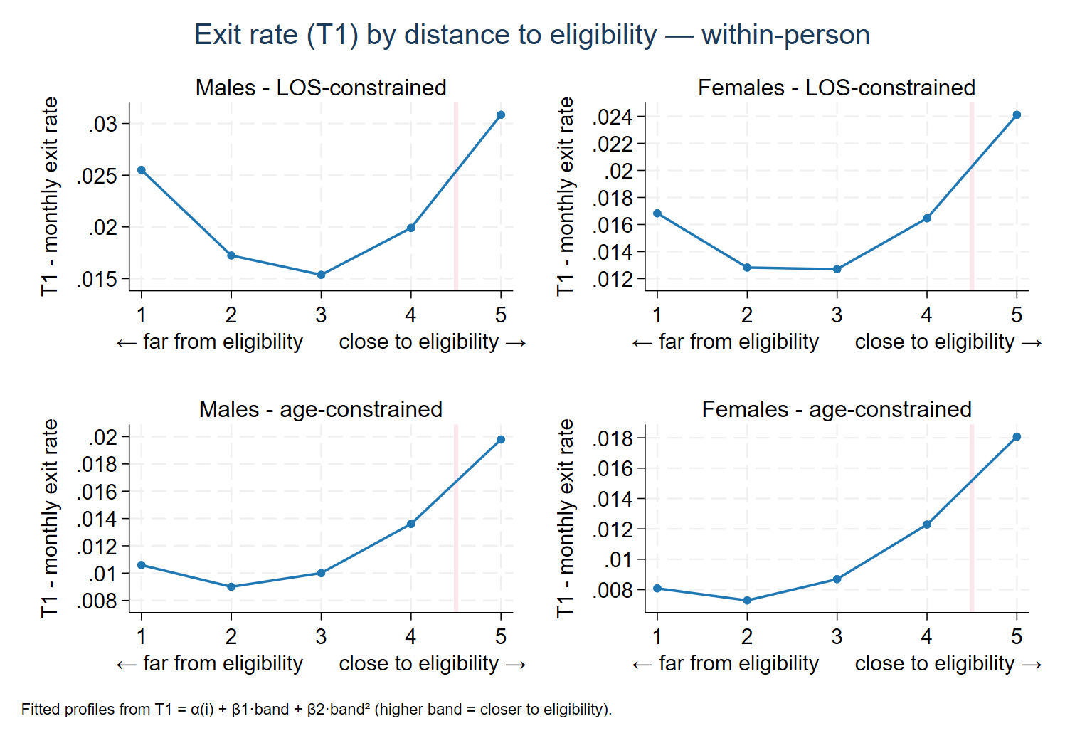
Figure 2. Monthly exit rate (T₁) by distance to eligibility, length-of-service-constrained (top row) and age-constrained (bottom row) workers, men and women. Each curve is a fitted within-person profile, quadratic in distance band, with higher bands closer to eligibility. T₁ traces a U in every panel: high far from eligibility, falling as the threshold becomes reachable, and rising into eligibility. The U is deep among length-of-service-constrained workers, where the far-side repel is pronounced, and much shallower among age-constrained workers, where the far arm is weak. Distance is the larger of the age gap and the length-of-service gap.
Read the exit curve from far to near. Far from eligibility, exit among length-of-service-constrained workers is high: a worker short of weeks, with little prospect of making them up, detaches from the system, the repel. As distance shrinks and the threshold becomes attainable, exit falls to a minimum, as the worker holds on to qualify, the pull. At the threshold itself, exit rises as workers who have just qualified retire. Age-constrained workers, who already hold the required weeks, trace a much shallower U: their far-side repel is weak, and the profile is dominated by the rise into eligibility. The deep U, and the repel that makes it deep, is a property of the length-of-service-constrained group, precisely where it was predicted to arise.
The exit result has a counterpart in the return rate. Figure 3 plots T₂, the monthly probability that an inactive worker resumes contributing, as the same fitted within-person profiles. Return is highest in the reachable middle range, where the prospect of qualifying draws workers back, and falls steeply into eligibility, where those who have qualified retire rather than re-enter. The shape holds for both constraint groups, reinforcing from the entry side what the exit rate shows from the exit side: behavior bends around eligibility, not around age as such.
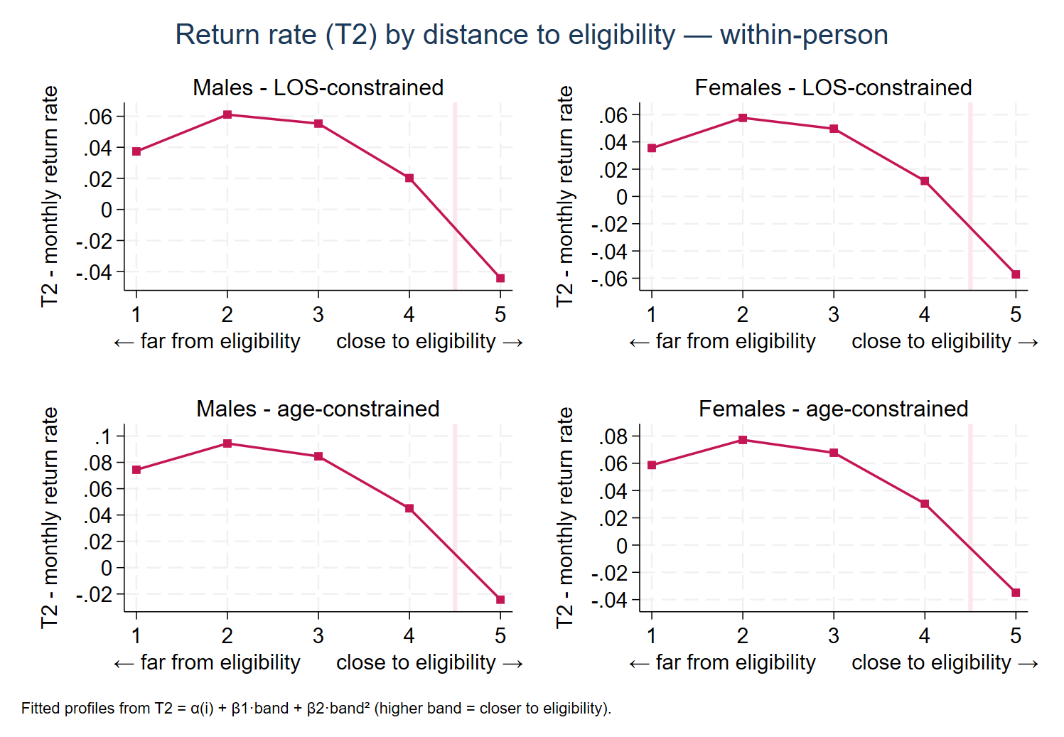
Figure 3. Monthly return rate (T₂) by distance to eligibility, length-of-service-constrained (top row) and age-constrained (bottom row) workers, men and women. Each curve is a fitted within-person profile, quadratic in distance band. Return peaks in the reachable middle range and falls steeply into eligibility, where qualified workers retire rather than re-enter. The fitted profile turns negative at the threshold; this is an artifact of the quadratic fit, not a negative probability. Distance is the larger of the age gap and the length-of-service gap.
The pattern is confirmed in estimation. Within-person fixed-effects equations for the exit and return rates, with distance entered in five-year bands oriented toward eligibility, so that a higher value means closer to the threshold, and a quadratic term,
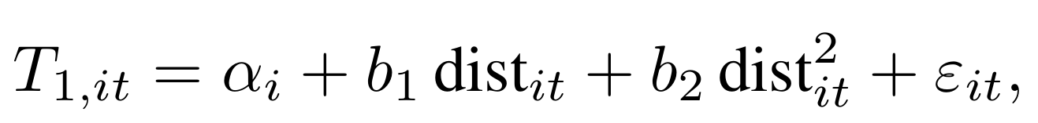
with the same specification estimated for T₂ and standard errors clustered by worker, trace two mirror-image curves, both coefficients estimated with high precision.
Table 3. Distance effect on the exit (T₁) and return (T₂) rates, per five-year band.
Transition rate | b₁ (per band) | t | b₂ (per band²) | t
Exit rate (T₁) | −0.0151 | −28.6 | +0.0035 | +27.0
Return rate (T₂) | +0.0863 | +22.6 | −0.0205 | −21.9
A single linear coefficient would misrepresent the exit curve. Because it is U-shaped, high far from eligibility, falling to a minimum in the middle range, and rising at the threshold, a straight line returns a slope dominated by the far region where most observations lie. The quadratic term is highly significant for both rates, and the return curve is the mirror image of the exit curve, peaking where the exit rate troughs and falling into eligibility. The figures, not the coefficients, are the result: the deep U among workers constrained by contribution weeks and the shallow one among workers constrained by age, which the pooled coefficients do not separate, is the contrast that identifies a response to the eligibility rule rather than to age.

7.4.4 A distance-based transition matrix tracks reform where an age-based matrix cannot
The pattern is tied to eligibility, not to turning 60, and this is what makes it consequential for reform. A transition matrix indexed to age is frozen under the rules in force when it was estimated: it records how a 59-year-old behaves today, when the retirement age is 60, and has no way to represent how that same 59-year-old would behave if the retirement age were 65. Yet that is precisely what changes under reform; the behavior between 60 and 65 shifts substantially, and a raised contribution requirement shifts it further. The behavior that responds to reform is the pension-system component, distinct from the labor-market forces that age captures, and separating the two requires a parameter that moves with the eligibility rules. Distance to eligibility is that parameter.
Which of the two conditions binds determines whether a worker is subject to the response. Figure 4 classifies workers at each age by their binding constraint, separately by gender and under two retirement ages: the age-binding zone (blue) is workers who will reach the contribution threshold before the retirement age, the length-of-service-binding zone (orange) is workers who will reach the retirement age first.
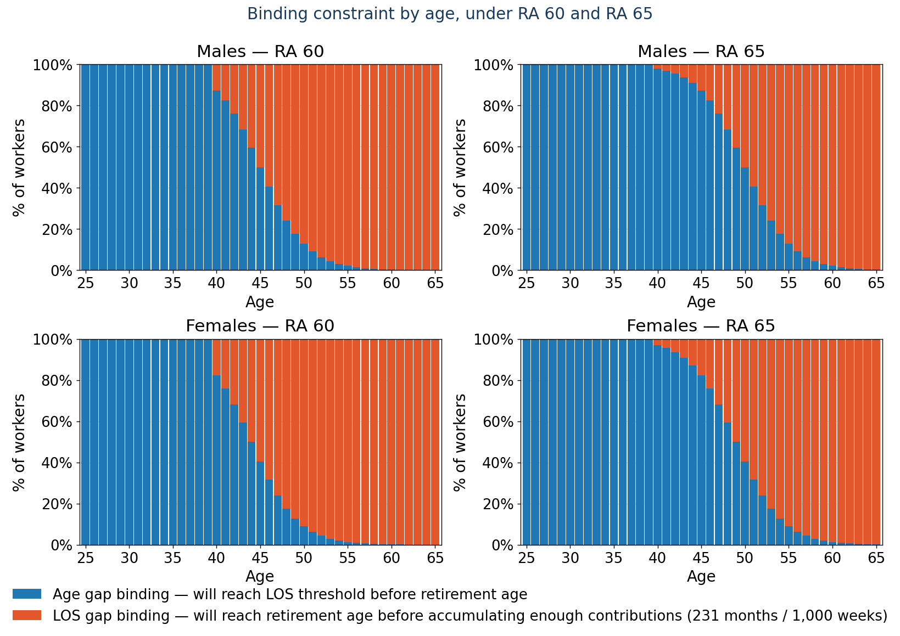
Figure 4. Share of workers age-constrained (blue) versus length-of-service-constrained (orange) at each age, by gender and under RA 60 and RA 65. The length-of-service-binding zone is where the contribution requirement, 231 months or 1,000 weeks, has not been met by the retirement age. Raising the retirement age from 60 to 65 shifts the boundary about five years to the right.
Raising the retirement age from 60 to 65 shifts the boundary roughly five years to the right: a worker length-of-service-constrained at 55 under RA 60 is age-constrained at 55 under RA 65. The mechanism is concrete at the level of a single worker. A 59-year-old sits about twelve months from eligibility under RA 60; under RA 65 the same worker sits about seventy-two months away, and their transition rates are read from the cell of the matrix that corresponds to the new distance, automatically, with no re-estimation. Because the pull-repel response lives in the length-of-service-constrained group, moving the boundary moves who is subject to the response. An age-based matrix cannot represent this: it fixes the retirement spike at 60 by construction and would keep projecting exits at 60 to 64 under a reform that makes retirement there impossible. A distance-based matrix relocates the spike because each worker’s distance is recomputed against the new rules.

7.4.5 The limit of the effect: reachable eligibility
The repel has a structural interpretation the model uses directly. A worker is subject to the pull only while eligibility remains reachable, while continued contribution can still close the length-of-service gap within a reasonable horizon. The principled criterion is a cost-benefit one: a worker stops having reason to contribute when the cost of the remaining required contributions exceeds the expected value of the pension they would draw, that is, when the contribution effort over the years still needed outweighs the replacement value accumulated over remaining life expectancy beyond the eligibility age. Figure 5 implements a simpler, transparent proxy for this limit: it separates, within the length-of-service-constrained zone, workers who can still reach the threshold by contributing continuously up to five years past the retirement age from those who cannot. The unreachable zone grows with age and marks where the pull no longer operates.
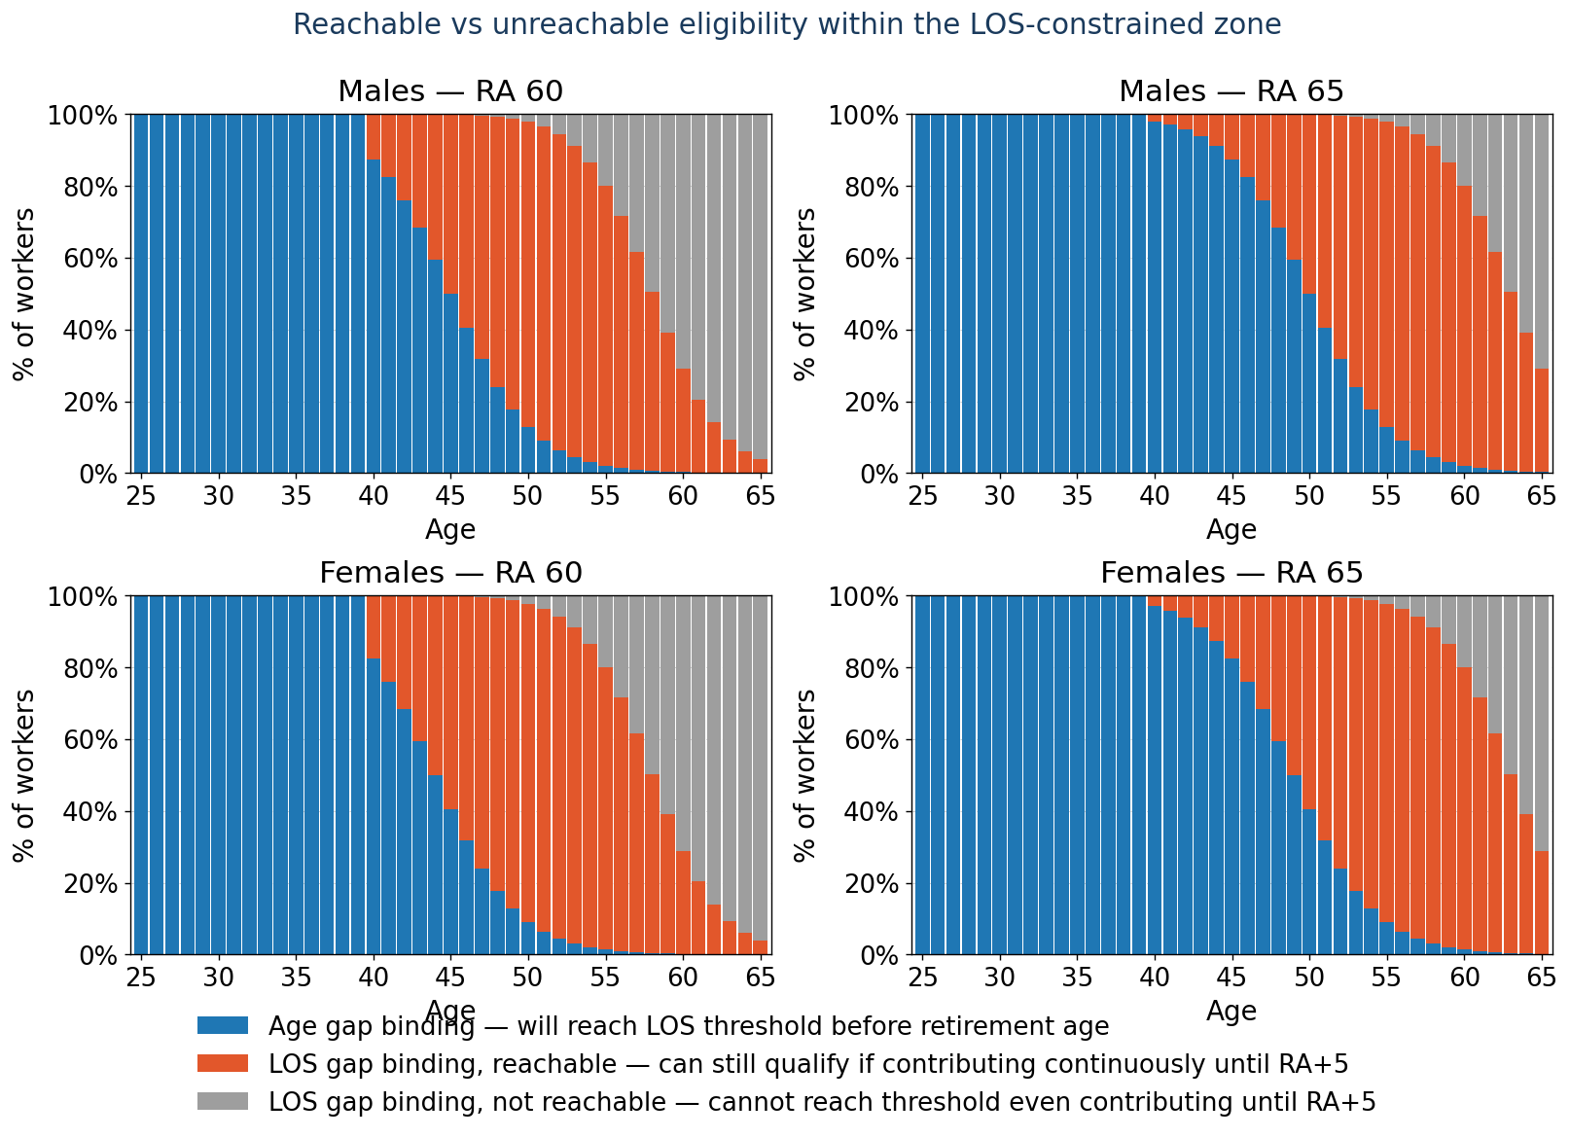
Figure 5. Within the length-of-service-constrained zone, by gender and under RA 60 and RA 65, workers who can still reach the threshold by contributing continuously to five years past the retirement age (orange) versus those who cannot (grey); the blue zone is age-constrained workers, who already hold the required weeks. The grey zone identifies where eligibility is no longer reachable and the pull no longer applies.
In the projection this enters as the indicator nohope, an indicator of unreachable eligibility, recomputed for each worker under whatever rules a scenario imposes. When a reform changes the retirement age or the required weeks, the indicator is re-evaluated and workers are redistributed between the reachable and unreachable groups; the behavioral response, pull where eligibility is reachable, repel where it is not, then follows the reform with no new assumption. The design separates what is labor-market determined from what is pension-system determined, so that when the rules change, only the pension-system component moves.

7.4.6 Where the repel is identified most cleanly
Within a worker’s career, distance to eligibility and age move almost in lockstep: for age-constrained workers, distance is an exact linear function of age, and the two effects cannot be separated, so the apparent pull in that group is not cleanly distinguishable from the ordinary tendency of older workers to exit less. The pattern is identified most cleanly among length-of-service-constrained workers, where distance is driven by the contribution gap and varies independently of age; the repel is the better-identified of the two regimes. The descriptive curves above also do not control for the duration of the current contribution spell, which is correlated with the contribution gap, so part of the within-person pattern may reflect duration dependence rather than the eligibility incentive. The production model controls for spell length directly through the term f(s,d); the figures should be read as evidence of the regime structure, repel, pull, and retirement, rather than as fully duration-adjusted rates.

8 Retirement, disability, and survivor rates (step 6)
The last pre-processing step prepares the rates that determine three flows out of the active population, the flows the contribution dynamics of Section 7 do not themselves generate: new old-age pensioners, new disability pensioners, and survivors. In PROST these are the retirement rate, the disability rate, and the survivor rate, each a schedule by age and gender. Each rate gives, for a worker of a given age and gender, the chance of taking up that benefit in a year. The engine does not currently drive any of the three flows from these rates, however: old-age retirement follows its eligibility rule rather than the retirement rate, and the disability and survivor draws are not yet switched on. The mechanism differs by benefit and is set out in the three subsections below. PROST also carries orphans as a fourth beneficiary category; the upgrade models the three flows above, with orphans not treated separately. In the rich environment all three rates are estimated from the beneficiary register with the help of a mortality table; default schedules stand in where local data are thin (Section 8.4).
The estimation uses one correction, for the following reason. Each of these rates is a flow: of all the people of a given age and gender, the share who took up that pension in a year. To estimate it from history one needs, for each past year, how many people newly took up each pension. The beneficiary register appears to supply this, since every pensioner on it carries the year their pension began. But the register is a snapshot of the living: it lists the pensioners alive in the base year, not those who first took up a pension in an earlier year and have since died. Counting today’s pensioners by the year their pension began therefore undercounts the original flow, and the undercount is worst for the oldest pensions and the oldest cohorts, exactly where the most recipients have since died. Left uncorrected, the rate would be biased downward, more so at older ages and further back in time. The correction offsets this: each survivor seen today is made to stand for a larger original group, larger by the inverse of the probability that a member of that group is still alive.
That probability is cohort survival, accumulated from the mortality table along each birth cohort. Because the register reaches back further than most mortality series, the table is first extended backwards, the earliest available rates copied to every year from 1850 onward, so that even the oldest cohorts have a mortality rate at each age they passed through. Survival is then built along the cohort, holding the year of birth fixed and letting age and calendar year advance together, as the product over age of one minus the mortality rate,
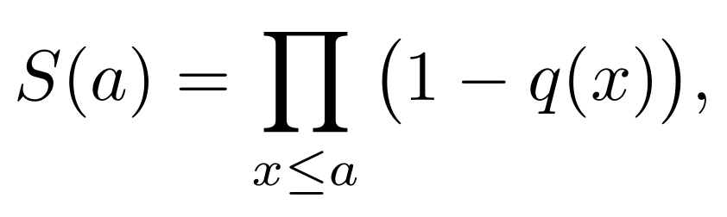
computed as the exponential of the cumulative sum of log(1−q), which stays numerically stable over the long horizons involved,
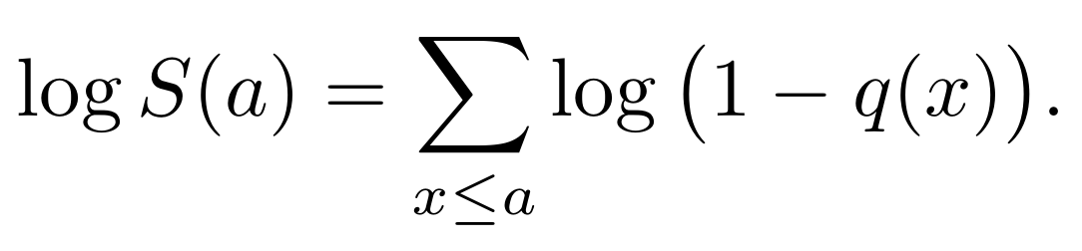
S(a) is the probability that a member of the cohort survives from birth to age a, and the ratio of two such values is the conditional probability of surviving between any two ages.
The correction is shown in full on the old-age flow in Section 8.1, then applied in the same way to the disability and survivor counts. In each case the survivors counted today are turned back into the original number of new pensioners by dividing out the conditional probability of having survived from the age at which the pension began to the present, read from the cohort survival above. The output of the step is, for each pension type, the derived original count of new pensioners by age, gender, and the year the pension began.
The schedule built here is a flow over the population: for each pension type, the derived new pensioners of an age and gender are divided by the historical population at the age and year the pension began, and the result is averaged over the most recent years, twenty in the pilot, to give a single schedule per type. The three subsections take the three flows in turn, old-age, disability, and survivor, giving the form each takes and what is specific to it; the final subsection covers the thin-data environments.

8.1 New old-age pensioners
The retirement rate is the rate at which workers take up an old-age pension: of the people of a given age and gender, the share that retired onto an old-age pension in a year. The engine does not apply this rate, however: old-age retirement is produced by the engine’s eligibility rule instead, and the rate is estimated and exported but not used. The whole sequence by which it is built is set out here, because the step that derives the new pensioners from their survivors is clearest on this flow.
The rate needs, for each past year, the number of new old-age pensioners at each age. What exists instead is the beneficiary register, a snapshot taken in the base year: the old-age pensioners alive now, each carrying their current age and the year they retired. The register is collapsed to counts, for every current age, gender, and year of retirement, how many such pensioners are still on it. These counts are not the new pensioners but their survivors: anyone who retired onto an old-age pension in an earlier year and has since died is no longer on the register, so counting today’s pensioners by their year of retirement falls short of the number who actually retired, and falls shortest for retirements long ago in old cohorts, where the most have since died.
The new pensioners are not observed directly; they are derived from the survivors on the register. To turn the survivors back into the new pensioners, each count is divided by the chance of having survived from retirement to now. The age at which a group retired is reconstructed from the snapshot, the current age less the years elapsed since retirement and floored at zero,
and the cohort-survival schedule of the section introduction is read at two points for that group’s birth cohort: survival to the age at retirement, S(age at retirement), and survival to the current age, S(age now). Their ratio is the conditional probability that someone who retired at the age at retirement is still alive at the current age. Because the count seen today is the original new pensioners already thinned by exactly this conditional survival, dividing it back out gives the number who originally retired,
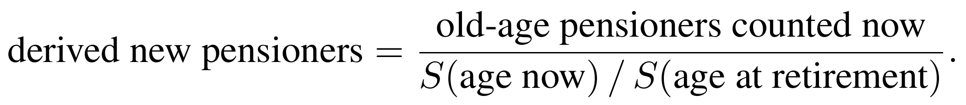
A worked case makes the step concrete. Take a group that retired onto an old-age pension at age 60 and is seen at age 90 in the base year, with cohort survival S(60)=0.85 and S(90)=0.40. The chance of surviving from 60 to 90 is 0.40/0.85≈0.47, so 100 such pensioners still on the register stand for 100/0.47≈213 who originally retired, restoring the 113 who have since died. A group seen a year or two after retiring is scaled by a survival near one and barely moves; the oldest, longest-ago retirements are scaled up the most.
The derived new pensioners are then expressed per head of the population of the same cohort at the age and year of retirement, where that population is available, which gives the share of that population that took up the pension, and the schedule is averaged over the most recent years, twenty in the pilot, to smooth year-to-year noise,
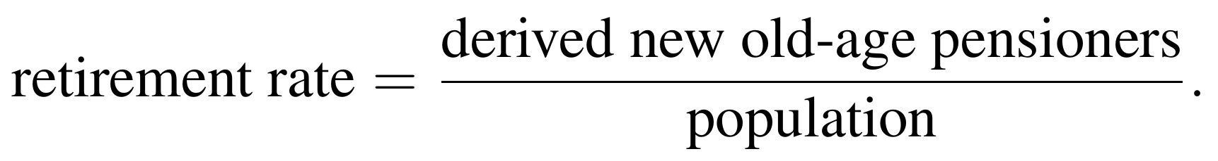
Two things are specific to this flow. The first is a refinement noted in the code but not yet carried out: the schedule should be indexed not by the observed age but by the implied retirement age, so that, like the transition rates of Section 7, it moves correctly when the retirement age is reformed. As it stands the rate is fixed to the observed age, so a reform that raised the retirement age would leave the old age-profile of retirement in place, with workers still shown retiring at ages the reform was meant to close off; indexing instead by the distance to the reformed retirement age would carry the schedule with the rule. The second is that the engine does not in fact draw against this rate at all. Old-age retirement in the projection is produced by the engine’s rule-based retirement decision, which moves an eligible worker into retirement once the replacement rate reaches the accrual ceiling or age passes a maximum; the retirement rate estimated here is therefore computed and exported but not used.

8.2 New disability pensioners
The disability rate, ds% in PROST, is the rate at which active workers move onto a disability pension. It is built from the disability counts exactly as the retirement rate is built from the old-age counts, the derived new disability pensioners of an age and gender per head of population,
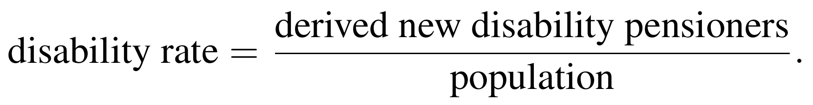
The mechanism is a direct draw: when it is switched on, each active worker of a given age and gender faces this rate as the chance of becoming disabled in the year, and a worker so drawn moves into the disabled state. In the engine’s order of outflows the draw is resolved after death and retirement, on the reasoning that a worker already eligible to retire will as a rule draw the old-age pension rather than pursue a disability claim, so that disability falls mainly among those not yet eligible to retire. At present the draw is not switched on: no active worker is moved into the disabled state, the corresponding step in the engine being a placeholder.

8.3 New survivor pensioners
The survivor rate, sp% in PROST, determines the opening of survivor pensions. It is built from the survivor counts as above, the derived survivors of an age and gender per head of population,

Its mechanism differs from the other two. A survivor pension is opened not when an active worker is drawn out of the active state, but when an affiliate dies and leaves a dependant, so switching the draw on requires the engine to keep a record of deceased affiliates, against which survivor pensions can be opened; both the draw and that record are pending. One further point is specific to this flow, and it is an error rather than a design choice: the current code forms the survivor rate from the old-age counts rather than the survivor counts, a copy-and-paste slip, which must be corrected before the rate is used.

8.4 Across the data environments
The three rates depend on a beneficiary register and a mortality table, which exist only in the richer environments.
- Rich environment (a register and a mortality table both exist). All three rates, retirement, disability, and survivor, are estimated as above, directly from the data.
- Low, very-low, and extremely-low environments. The register and the long mortality series are precisely what these environments lack, so the three rates are supplied from default schedules rather than estimated.
The schedules are prepared and saved in every case. As set out above, though, the engine does not currently draw against any of them: old-age retirement is produced by the engine’s retirement rule, and the disability and survivor draws are not yet switched on.

9 The projection engine
The PROST Upgrade microsimulation model is built on a single simulation engine. It holds a population of individual records and advances it forward over a projection horizon of more than eighty years, one year at a time, and within each year at monthly resolution for the parts that need it. As it runs it creates new affiliates, draws contribution transitions, mortality, and movements into retirement, applies the benefit rules to those who qualify, and accumulates each person’s length of service, account balance, and accrued rights. The engine is the same in every application; what differs between countries is only the inputs it is given, and building those inputs is the subject of the rest of this note. This section sets out the engine itself: the records it works on, the order in which it processes each year, and the rule behind each step.
To run, the engine needs six inputs, each prepared by one step of the pre-processing pipeline.
Table 4. The six inputs the engine consumes, and where each is built.
Step | Produces | Role in the engine | Built in
1 | Life-cycle wage growth profiles | How each worker’s wage evolves | Section 3
2 | Base-year dataset | The starting population of affiliates | Section 4
3 | Beneficiary database | The current pensioners carried into the projection | Section 5
4 | Affiliation rates | The number and profile of new affiliates each period | Section 6
5 | Transition rates T₁, T₂ | The monthly contribution dynamics: new actives and new inactives | Section 7
6 | Retirement, disability, survivor rates | Movement out of the active population into benefits | Section 8

9.1 The population and its state
The engine works on a register of individuals, each carrying an age, gender, wage and wage decile, length of service and length of affiliation, contribution density, individual account balance, accrued rights, a status, and, in a sampled base-year file, a weight. The status records which of five states the individual is in: alive and affiliated, retired, disabled, widowed (in receipt of a survivor pension), or dead. The projection runs from a base year, calibrated to 2024 in the pilot, forward year by year to the projection horizon. Working age is taken as fifteen to sixty-four, used only for reporting and not in the projection itself. The weight lets population totals be recovered when results are aggregated. Throughout this note i indexes an individual, t a month within a projected year, and y the year, so the subscripts on a quantity show what it varies over: a wage wᵢₜ changes by person and month, while an economy-wide growth rate carries only a year subscript.

9.2 The order of stages within a year
The projection advances one year at a time, and within each year the engine applies a fixed sequence of stages, the same sequence every year, so that a reform enters simply by changing the parameters that sequence reads. The order matters, because several stages depend on the state the earlier ones leave behind, and the sequence is set out in full before the individual rules are given.
The year opens by resolving every benefit and labor-market parameter for that year from the dated tables, the retirement ages, the minimum contributory period, the accrual rates, and the rest, so that the rules applied are those in force in the year being projected. A fresh cohort of new affiliates is then created from the affiliation rates and added to the register. The surviving population is carried forward and aged by a year, and the derived quantities, length of service and affiliation, contribution density, the length-of-service gap, and the pension-rule indicators, are recomputed. Mortality is then applied, removing those who die in that year. The contribution transitions follow, drawn month by month from the two transition rates T₁ and T₂, moving workers between the active and inactive states and advancing each worker’s service and spell length. Wages are grown for the year. Pensions already in payment are indexed, and the average covered wage that the defined-benefit formula will use is brought up to date. The individual accounts of defined-contribution members are credited with the year’s contributions and investment return, and the defined-benefit replacement rate and pension are computed for everyone who might retire. The retirement decision is then taken, moving the newly retired into the retired state and, for defined-contribution members, converting the account balance to an annuity. Finally, the year’s flows are tallied and the workers who have just retired are written to the separate beneficiary database, to be carried forward as pensioners. The disability and survivor draws would sit within this sequence, after the retirement decision, but are not yet switched on, as noted where those pensions are described. Within this sequence only the contribution transitions are genuinely monthly. Mortality and the retirement decision are each settled once a year, mortality as a single yearly draw placed in a randomly assigned month, and retirement at the year end after the twelve months of contribution have run; the benefit and account calculations on which retirement depends are likewise computed once a year. Running these steps annually rather than month by month is a deliberate choice, made to improve computational speed.
This entire sequence is the same in every data environment. The flows it produces, the new old-age retirees, the workers newly leaving or resuming contribution, and the new affiliates, are generated by the same engine whether the country’s data are rich or sparse; what changes with the data environment is not the projection but the estimation of the rates that feed it, the contribution transition rates T₁ and T₂ that drive the moves into and out of contribution (Section 7.3) and the affiliation rates that set the inflow of new affiliates (Section 6). The retirement decision likewise applies the same rule and reads the same dated parameters everywhere.
Each of these steps is set out in turn below.

9.3 New affiliates
At the start of each year a fresh cohort of new affiliates, distinct from newly active current affiliates and from the base-year population, is generated from the affiliation rates of Section 6. The rate for each age and gender is multiplied by the projected population to give an expected count, which is rounded and realized as that many individual records. Each new affiliate begins alive and affiliated, with length of service and length of affiliation at zero, contribution density at one, a randomly assigned birth month and death month, a wage decile drawn uniformly across the ten deciles, and a starting wage drawn from a normal distribution with the mean and standard deviation of active workers in that decile in the base year, held within the decile’s observed minimum and maximum. Their length-of-service gap therefore opens at the full minimum contributory period, and the remaining covariates take their natural starting values. Each is also assigned, once and for life, to a pension system, defined-benefit or defined-contribution, according to whether the year of entry falls before or after the defined-contribution reform. From the first month a new affiliate is treated exactly like any other worker: the transition rates determine their contribution, the seniority factor their wage, and their service and gap evolve as they contribute.

9.4 Mortality
Mortality is decided once a year. At the start of the year each living worker draws a single uniform random number, and it is compared against the mortality rate q(a,g,y) for their age, gender, and year, read from a mortality table held flat beyond its last available year. The worker dies in the year if the rate exceeds the draw, but the death is stamped not at the moment of the draw: it is placed in a month fixed in advance for that worker by an independent uniform draw over the twelve months, and the move to the dead state occurs only when the running month reaches it,
Two features follow from this design. The chance of dying is annual, a single test against the yearly rate, but it is dropped into the year at a random month rather than applied afresh each month, which spreads deaths through the year at a fraction of the cost of twelve separate tests. And because the death month is assigned when the worker enters rather than when they are found to die, a worker who dies part-way through a year stops contributing from that month and, if already retired, stops drawing a pension, so the within-year timing of the exit is preserved without being re-decided every month.
Aging is placed within the year in the same way. A worker’s age rises by one not in a fixed calendar month but in their own birth month, so that age, which feeds the contribution transition rates and the eligibility test, advances at a different point in the year for each worker rather than for the whole population at once.

9.5 Using T₁ and T₂: the contribution transitions
The transition rates T₁ and T₂ are what the projection moves workers by, for the reason given in Section 7.1: a single contribution density cannot drive the projection on its own, because it is blind to the order of the months it averages and cannot adjust to different demographic and economic conditions. T₁ is a worker’s monthly probability of leaving the contribution state (i.e., formal employment) and T₂ the monthly probability of returning, and read together with the spell length, the months already spent in the current state, they carry the persistence that a single density cannot hold: a worker deep in a stable spell has a low exit rate, one who has just entered is more exposed.
These two rates are estimated beforehand, once, from past data, by a method that depends on the quality of the data is a given county. The projection engine does not estimate them; it takes them as given and applies them. Whether each worker contributes is then resolved month by month within the year in three parts: the two rates give each worker an individual probability of moving, a common scaling ties the total number of moves to the year’s labor-market targets, and a random draw settles each worker’s case.
The two transition rates are evaluated first. The saved contribution model, fitted on past data, is applied to each worker’s current covariates and returns two monthly probabilities: for an active worker, the probability of leaving contribution, the exit rate T₁; for an inactive worker, the probability of returning, the re-entry rate T₂. At this point the two are the raw model probabilities, before any adjustment.
Left as they are, the raw rates would imply some expected number of newly inactiveand newly active affiliates that need not match the labor-market path the user has set for the year. Each rate is therefore multiplied by a common scaling factor, one for the newly inactive and one for the newly active, chosen so that the expected number of moves equals a target. The newlyinactive target follows from a turnover assumption. The turnover rate is the annual count of status changes, newly inactive plus newly active, expressed as a share of the affiliate stock,
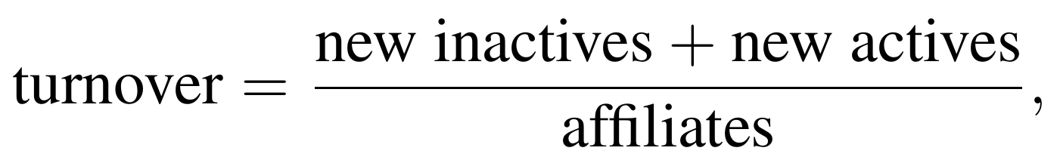
a figure the user supplies among the labor-market inputs rather than one the model estimates. Setting newly inactive equal to newly active, which holds absent a trend in the employment rate because the active stock is then stationary, and inverting gives the target number of each,
The scaling factor for the newly inactive is then the target divided by the expected number the raw rates produce, the sum of the exit rates over the active workers,
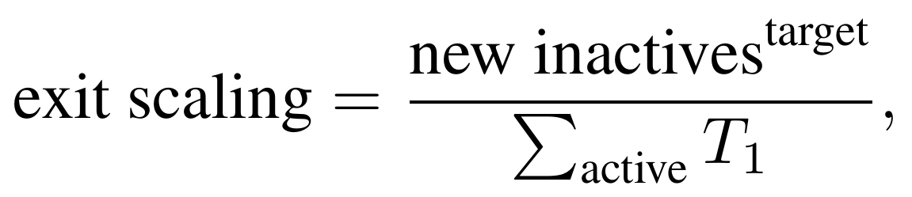
and every worker’s exit probability is multiplied by the exit scaling, so the expected number of newly inactive equals the target by construction. The new-actives side is handled the same way, with the re-entry scaling the ratio of the new-actives target to the sum of the re-entry rates over the inactive workers. When the user sets a rising employment rate the new-actives target is lifted above the newly-inactive target by the implied increase in the active stock, so that the inflow and the outflow together carry the employment rate onto its assumed path rather than merely holding it level. The scaling fixes the expected number of moves, not the number actually drawn, so the realized totals match the targets only in expectation; forcing an exact match would require a further adjustment after the moves are drawn.
The scaled rates are resolved one month at a time. In each of the twelve months every worker draws a single uniform random number, and the draw is compared with the worker’s rate: an active worker leaves contribution when the draw falls below the exit rate, and an inactive worker resumes when the draw falls below the re-entry rate,
where an active worker is one with a positive wage decile and an inactive worker one whose decile has been set to zero. Because the draw is taken afresh each month, a worker’s exposure to a move is spread across the year rather than decided once.
The covariates of the workers who move are then updated. A worker who becomes a new inactive has their wage decile set to zero, the marker of inactivity, and their contribution density begins to fall; a worker who re-enters has their decile restored and is assigned a wage, their saved reference wage where they have one and a fresh draw from the decile otherwise; and both have their spell length reset to one, since a new spell has begun. A worker who does not move has their spell length incremented by one, carried a month deeper into the current spell.
This evolving spell length is what lets the model distinguish a stable career from constant churning. It enters the transition rates through the term f(s,d), in which s is the spell length and d the wage decile, so the probability of moving depends on how long the worker has already been in the current state and where they sit in the wage distribution. Once the twelve months have run, length of service, length of affiliation, contribution density, the length-of-service gap, and the two pension-rule indicators are recomputed for everyone, so the next year opens from a consistent state.

9.6 New actives and new inactives
Beyond moving individual workers, this step generates the two contribution flows that, with the new affiliates of Section 9.3, drive the active population each period. A new inactive is an active worker who has just stopped contributing; a new active is an inactive affiliate who has just resumed. Both are already in the system, which sets them apart from a new affiliate, who enters for the first time. An active worker becomes a new inactive when the monthly draw falls below the exit rate, u < T₁; an inactive affiliate becomes a new active when the draw falls below the re-entry rate, u < T₂. At the year end the two are counted across the population,
(In the code these counts are the variables exiters and reentrants.) The counts, with the new affiliates, carry the contributing population from one year to the next and feed the labor-market accounting. The contributing stock is the number presently contributing, coded employment; the rest of the affiliated population is non-contributing, coded unemployment, so
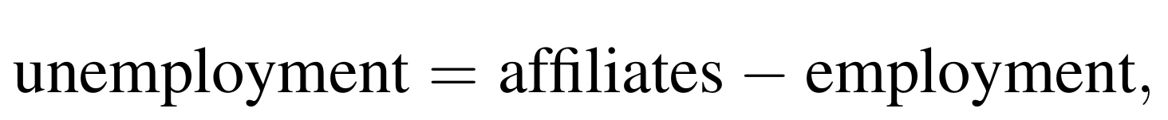
and the share of affiliates contributing is the employment rate. Each flow is read against the stock it leaves,
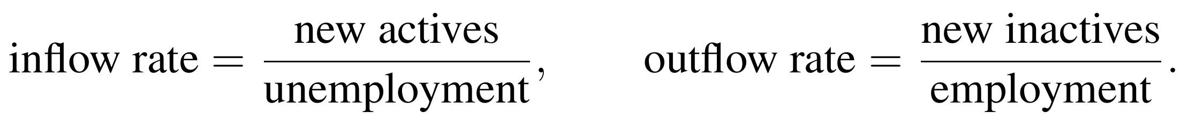
The common scaling factors of Section 9.5, the exit scaling and the re-entry scaling, hold these realized flows to the user’s labor-market path: the exit scaling holds the outflow to the turnover target, and the re-entry scaling raises or lowers the inflow so the employment rate follows its assumed trajectory. The realized turnover the code reports alongside these divides the two flows by affiliate-months rather than by the affiliated stock, and so sits on a different basis from the turnover target that anchors the calibration; the two would need to be put on a common basis before being compared directly.
The draw above is the same for every worker: the exit and re-entry rates are applied to all active and inactive affiliates alike, with no split by pension system. Each worker, though, carries a system, defined-benefit or defined-contribution, and the new actives, the new inactives, and the stocks are reported by that system in the output. The system each worker carries is set at first affiliation (Section 9.3), in the pilot at the 1997 boundary that separates the transition generation, on the old defined-benefit rules, from the individual-account generation.
The transition dynamics are common to both systems, but the pension is not: a defined-benefit worker accrues a pension on a covered wage, while a defined-contribution worker accumulates an individual account, each computed only for the workers in that system, and a worker draws nothing from the system they are not in (Sections 9.9 and 9.10). The beneficiary database carries the same split from the start, every pension classified by system, defined-benefit or defined-contribution, and by kind, old-age, disability, or survivor, the six categories of Section 5.

9.7 Wages in the projection
This is where the engine applies the wage model that Section 3 estimated: the life-cycle seniority shape that tilts growth over a career, and, for any worker without an observed wage, the regression that supplied one. Section 3 was concerned with how that model is obtained from data of varying richness; this section is concerned with what the engine does with it each year. Each worker’s wage grows once a year, and the growth has two parts: an economy-wide rate the user sets as a target for the year, and a seniority factor that tilts that common rate by where the worker sits in their career. The two are combined for each worker, applied to the wage, and then a single rescaling pins the average back to the user’s target.
The economy-wide target gtargetᵧ is the average pace the user assumes for year y, read from the wage-growth input. It is the rate the aggregate wage bill is meant to grow at, before any individual differences. The seniority factor is the fitted profile r̂(d,g,a) of Section 3, read off the worker’s current wage decile d, gender g, and age a by evaluating the saved model. It is a relative growth, a ratio around one, the cohort’s growth measured against the economy’s: a worker whose factor exceeds one grows faster than the economy in that cell, typically the young, and a worker whose factor is below one grows more slowly, typically those late in their careers whose wages have flattened. A value of one reproduces the economy-wide rate exactly, so the factor multiplies the target directly. The projection holds each worker’s wage decile fixed, although in the data workers move between deciles over a career.
The growth actually applied to a worker is the economy-wide target tilted by their seniority factor, and each wage is first carried forward by it to a provisional value ,
so two workers in the same year grow at different rates, and the spread of wages across the workforce widens or narrows as the seniority profile dictates.
One correction remains, built into the design. The seniority factors average to one across the whole workforce, so the average mix of workers would grow exactly at the target. But the workers present in any single year are not that average mix, and the mix shifts as they age, retire, and move in and out of contribution, so the growth they actually produce comes out a little off. The model measures what it produced, the realized growth grealizedᵧ, this year’s mean wage over last year’s minus one, and scales every provisional wage by the single factor that closes the gap,
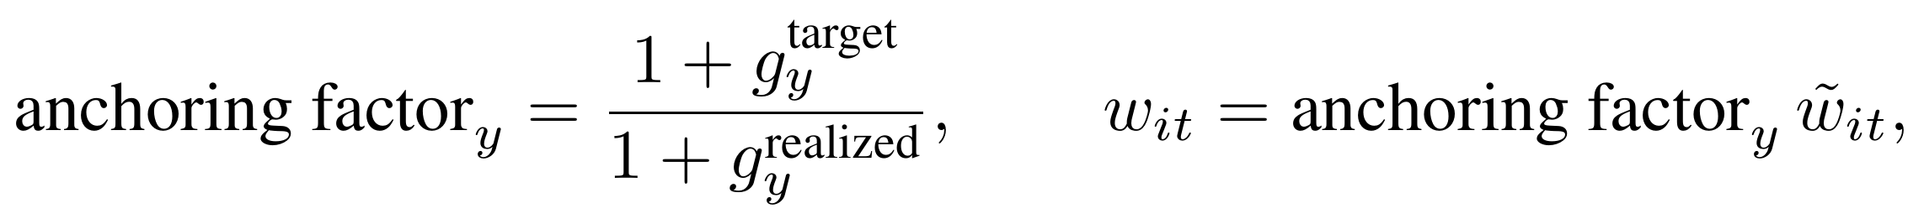
which gives the final wage and pins the aggregate to the user’s target exactly. The anchoring factor falls just below one when the year ran above target and just above one when it ran below; because it is the same for every worker, the seniority tilt just applied is left untouched, and only the common level moves, never the spacing between workers. The saved reference wage is scaled by the same factor, so it stays in step.
A worker returning from inactivity is restored to that saved reference wage adjusted for intervening wage growth, rather than re-drawn, so a career interruption does not erase wage history and leaves room to apply a return penalty in a later model revision. This re-entry reference is distinct from the defined-benefit average covered wage, the base for the pension, which is a valorized average of past covered wages over a window set by the scheme, formed as set out with the benefit formula below.

9.8 Valorization and indexation
Two distinct adjustments keep the system in step with prices and wages, and the model keeps them apart because they act at different points in a worker’s life;
- Valorization adjusts a worker’s past earnings when calculating reference wages for pension benefits, bringing each prior year’s wage up to date for the change in the cost and standard of living between the year it was earned and the year of retirement; it becomes a policy issue only because the defined-benefit pension rests on an average of past wages rather than on the final salary alone.
- Indexation adjusts a pension already in payment, growing it after retirement so that its value is maintained year by year. Both are set out here, before the defined-benefit pension that draws on them, so that the pension formula can be written in terms already defined.
The two rest on one three-part formula, a weighted combination of price inflation, real wage growth, and a user-set anchor, each a percentage that enters a growth factor as one plus the rate. Each carries its own coefficients and so is a distinct rate. The valorization rate, which acts on past earnings, is
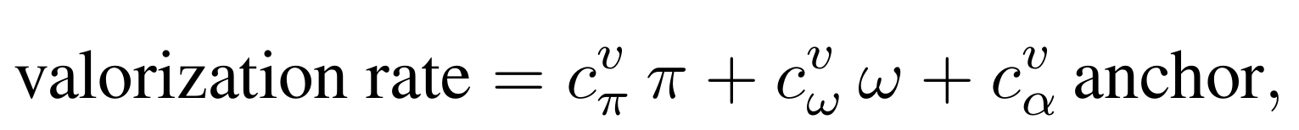
and the indexation rate, which acts on pensions in payment, takes the same form with its own coefficients,

The minimum and maximum pension are carried forward by a third rate of the same formula, the minimum-pension-indexation rate. The three differ only in their coefficients, so a country that indexes pensions in payment to prices but valorizes past wages to wage growth is represented by different coefficient sets, not by different mechanisms.
The valorization policy is a choice of the valorization coefficients. A policy of no valorization sets all three to zero, so past earnings enter the pension formula at their raw nominal values. Price valorization sets the inflation coefficient to one, so each prior wage is revalued by price inflation alone. Wage valorization sets the inflation and real-wage coefficients to one, so prior wages are revalued by the change in average earnings, that is by price inflation plus real wage growth.
Valorization is carried out by bringing each past wage forward to the year of retirement. A wage earned in year j is multiplied, once for every year from then to the retirement year T, by one plus that year’s valorization rate, so the valorized wage is the original wage compounded by the valorization rate over the intervening years,
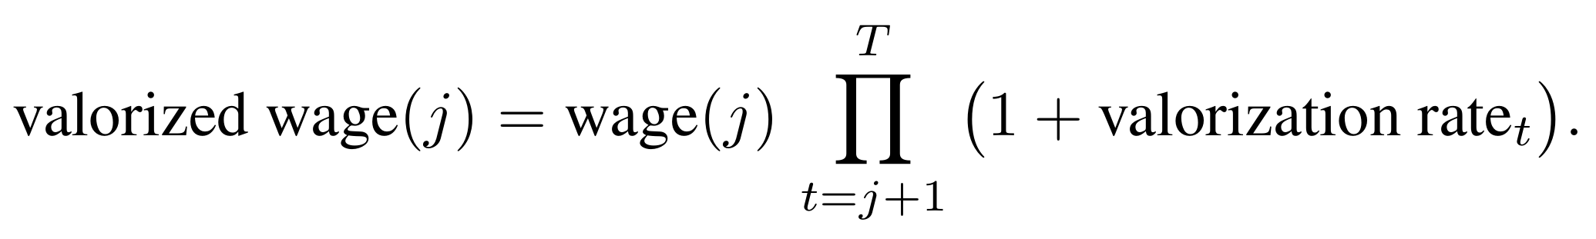
Under a constant rate this reduces to the wage times one plus the rate raised to the number of years, and under no valorization the product is one and the wage keeps its nominal value.
Indexation acts in the same shape, but on a pension already granted rather than on a past wage. Once a pension is in payment it is projected forward each year by one plus the indexation rate,
so a pension awarded in one year keeps its value against prices and wages in every year after; this is the projection rule the engine applies to every pension in payment, year by year. The minimum and maximum pension that bound the benefit are carried forward in the same way, each year, by the minimum-pension-indexation rate (the mpi_rate in the code),
so the floor and the ceiling keep pace with the pensions they bound. It is the valorized wages, not the raw ones, that the defined-benefit base of the next section averages.

9.9 The defined-benefit pension
A worker who retires from a defined-benefit scheme receives a pension built from three ingredients: an average covered wage, a replacement rate, and the floors and ceilings that bound the result. The first of these, the average covered wage, is the earnings base of the pension, and the way it is formed is itself a policy choice that differs from one country to the next.
The base is an average of the worker’s past covered wages, but two things about that average are set by the scheme rather than fixed by the model: how many years enter it, and which years. The model exposes both as parameters, so that a single engine can reproduce the full range of national rules. The number of years, written N, can be one, a handful, or the whole career, and the selection rule can take the most recent years, the highest-paid years, or the highest-paid among the most recent. The common cases are a final-salary scheme, where N is one and only the last covered wage counts; a last-few-years scheme, where N is, say, five or ten and the average runs over the most recent N years; a best-years scheme, where the N highest covered wages over the career are averaged, in some countries restricted to the N highest within a fixed recent window; and a full-career average, where every year the worker contributed enters the mean.
Whatever the window, the wages in it enter not at their face value but valorized, each brought to the value of the retirement year by the valorization rate of Section 9.8, so that a wage earned long before retirement is not weighed at its outdated nominal value against a recent one. The base is the average of these valorized wages over the chosen years,
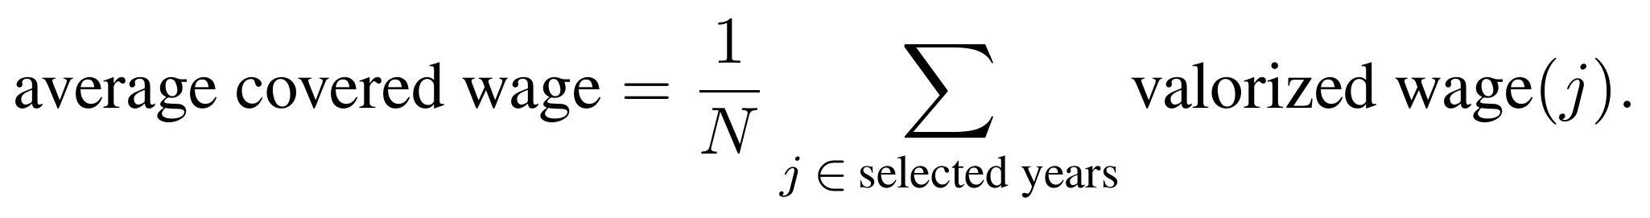
the number N and the membership of the set of selected years together carry the scheme’s choice of window, while the valorization carries the adjustment to current values. A final-salary rule is this same expression with N equal to one, and a career average is the same expression with the set of selected years running over the worker’s whole contributory history.
The replacement rate is the years of service times the accrual rate, reduced by a penalty for each year of early retirement and increased by a bonus for each year of late retirement, then bounded below by zero and above by a maximum accrual,
The monthly pension is the average covered wage times this replacement rate, bounded below by a minimum pension and above by a maximum pension,
A worker who retires without the service needed to qualify receives instead a lump sum, namely their own contributions accumulated with interest, computed from their length of service, the average covered wage, the employee contribution rate, and a lump-sum interest rate.

9.10 The defined-contribution pension
A worker in a defined-contribution scheme accumulates an individual account. The contribution paid in each period is the sum of the employer, employee, and government shares, each a rate applied to the worker’s covered wage within the relevant income bracket,
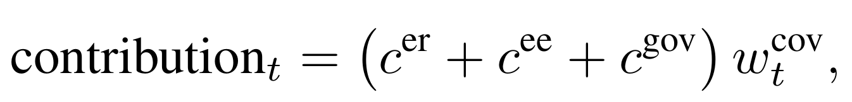
and the account earns an investment return net of the management fee charged by the fund administrator, the gross return less the fee,
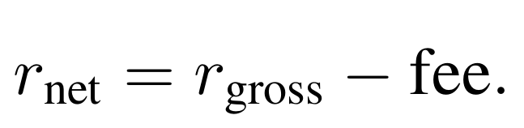
The fee is the management charge the pension fund administrator levies on the account, set as a proportion of the assets it holds, the management expense ratio; in the pilot it is the commission the private administrators, the AFOREs, deduct each year. It is supplied by the user among the defined-contribution parameters, year by year and alongside the gross return, and it is subtracted from that gross return, so that what the account actually earns is the net return. The charge is modest in any single year but compounds over a working life, so a higher fee lowers the accumulated balance, and the annuity bought from it, by considerably more than its annual size would suggest; this is why it is carried as a parameter in its own right rather than folded into the return the user sets.
Each period the account takes the previous balance plus the period’s contribution and earns the net investment return,
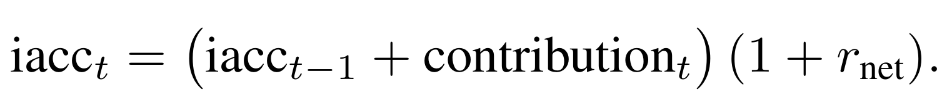
At retirement the balance is converted to a monthly annuity by dividing by twelve times an annuity factor that reflects life expectancy and the discount rate,
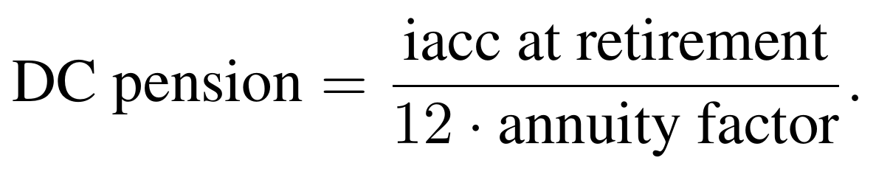
This balance-over-annuity rule is the standard approach to defined-contribution pensions, in which the pension is the accumulated individual balance divided by an annuity factor; the difference here is that the calculation runs on each worker’s own account rather than on a cell average, and the return credited is net of the management fee.
Where the worker is eligible for a minimum pension the annuity is topped up to it; where the worker is not eligible for a pension at all, the balance is paid as a lump sum.

9.11 The retirement decision
Whether a worker retires is decided in two steps. Eligibility comes first: a worker can claim an old-age pension once length of service has reached the minimum contributory period, age has reached the earliest retirement age, and age is high enough that the early-retirement penalty does not on its own drive the replacement rate to zero. These thresholds are read from the dated parameter tables and so can shift under a reform,
with 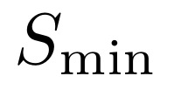 the minimum contributory period in years,  the earliest retirement age, R the normal retirement age, and penalty the per-year early-retirement reduction in the replacement rate. The third factor is a floor on age: because the replacement rate loses the penalty for each year below R, at 1/penalty years below it the accumulated reduction reaches one, large enough to cancel any replacement rate, so a worker further below R than that draws no positive pension and is not counted as eligible. In the current version this third factor is dropped, so eligibility rests on the first two; early retirement is not yet modeled but is planned for a later revision. The decision itself is, at present, a deterministic default: an eligible worker retires, moving into the retired state, as soon as either the replacement rate has reached its maximum, so that a further year of contribution would add nothing to the pension, or the worker has passed the age beyond which retirement is compulsory,
where the replacement rate is as defined in Section 9.9, 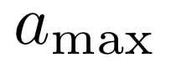 the maximum accrual, and 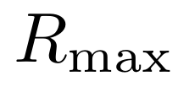 the compulsory retirement age. This rule is a placeholder, and two complementary refinements, neither yet implemented, would improve it.
The first is to let the decision respond to eligibility as it changes over time, which is the property a credible treatment of reform requires: when the retirement age or the minimum contributory period is altered, the decision should move with it. Much of this is already in place, because eligibility Eₜ is read from the dated rules rather than from a fixed age, so even under the present default the decision shifts when those rules are reformed; what remains is to carry that responsiveness through into the timing of retirement, and not just the threshold at which it first becomes possible.
The second is to base that timing on the value of deferring rather than on a mechanical trigger. Here a worker compares the expected present value of retiring now against deferring, and retires once deferring no longer pays. Writing Pₜ for the monthly pension a worker would draw by retiring at age t, v for the annual discount factor, and 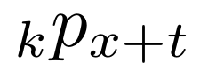 for the probability of surviving a further k years from age x+t, the expected present value of retiring at t is
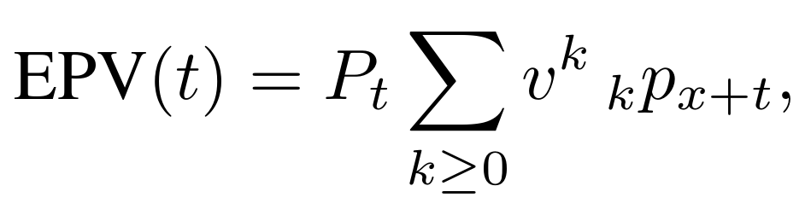
and the worker retires at the age that maximizes it, deferring only while another year still raises it,
where t₀ is the first age at which Eₜ = 1. This weighs the extra pension another year of contribution would bring against the mortality risk and the year of pension forgone.
The two go together. A value-based rule of this kind, gated by an eligibility that itself moves with the rules, would deliver both at once, the rule-responsiveness of the first and the behavioral timing of the second, since the pension Pₜ and the eligibility ages it depends on are all read from the dated tables. Both are directions worth considering rather than settled choices, and worth adding only if done properly: a partial version that did not respond correctly to the rules would be worse than the transparent default, so until they can be specified with care the default is kept.
One point on the mechanics of the current default: the decision is taken once a year, at the end of the year and only after the twelve monthly contribution draws have run, and a worker who retires is dated to December, so one who becomes eligible in, say, April keeps contributing to the year end before retiring; this, with the benefit and account calculations it depends on, sits outside the monthly loop and is computed once a year, for speed. A worker who retires from a defined-contribution scheme has the accumulated balance converted to an annuity at this point, as set out above.
The retirement decision sits within a fixed order of outflows. Within each projected year a worker can leave the active population in three ways, and when all three are switched on they are resolved in the order death, then retirement, then disability, with disability taken last (Figure 6). The reason is behavioral: a worker who is already eligible to retire will as a rule draw the pension rather than undertake the heavier administration of a disability claim, so disability bites mainly among those not yet eligible to retire. Work-injury disability, which in some systems pays more than the ordinary old-age pension, may merit separate treatment. At present only death and retirement are drawn; disability is prepared but not yet activated.
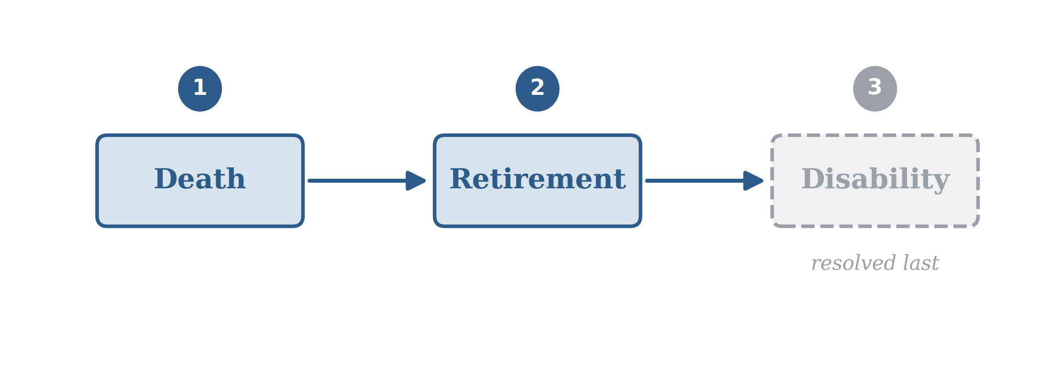
Figure 6. The intended order in which outflows are resolved once the disability and survivor draws are switched on: death, then retirement, then disability. Disability is taken last because a worker who is eligible to retire will generally draw the pension rather than pursue a disability claim.

9.12 Disability and survivor pensions
Disability and survivor pensions are part of the same design and their rates are prepared (Section 8), but the corresponding draws are not yet switched on in the projection: no worker is presently moved into the disabled state, and no survivor pension is opened when an affiliate dies. When they are switched on they take their place in the order of outflows set out in the retirement decision above, after death and retirement. The survivor draw also requires the engine to retain a record of deceased affiliates, itself a pending item.

9.13 Parameters, reform, and the model’s inputs
Every parameter of the benefit rules, the retirement ages, the minimum contributory period, the accrual and maximum-accrual rates, the early and late adjustment factors, the minimum and maximum pensions, the employee and employer contribution rates, the pensionable-income floor and ceiling, and the valorization and indexation coefficients themselves, is supplied externally, in dated tables, and resolved afresh at the start of each projected year. A reform is therefore expressed by changing a parameter from a given year onward, not by changing the engine: raising the retirement age, lengthening the minimum contributory period, or altering the accrual rate is a change to a dated table, and the same engine projects its consequences.
Across all of these inputs, the model draws on two kinds of information, which come from different places and carry different status. The first kind is estimated from the country’s own microdata: the starting population, the stock of pensioners, the affiliation rates, the transition rates T₁ and T₂, the wage profiles, and the retirement, disability, and survivor rates are all produced by the pre-processing pipeline from the observed records, and they describe how the system has behaved. The second kind is assumed, supplied to the model from outside rather than estimated within it: the forward path of economy-wide wage growth, price inflation, and real wage growth; the employment-rate growth and the turnover target that anchor the labor-market projection; the financial assumptions for funded schemes, the gross return, the management fee, and the annuity discount rate; the demographic projection of the population by age and gender; and the policy parameters themselves. These are not learnt from the data. The macroeconomic and financial paths come from the client’s own framework or are set as scenario inputs by the user; the demographic projection is taken from an external source, the United Nations projections in the pilot; and the policy parameters are the rules of the scheme as written in law. The mortality used to age the population and to derive past flows (Section 8) sits between the two, observed historically and then held or projected forward by assumption. The division matters for reading any result: the estimated inputs fix how workers and pensioners behave, while the assumed inputs are the conditions under which that behavior plays out, and it is the latter the user varies to ask what a different macroeconomic path, or a different reform, would imply.

Note this is a Kaplan-Meier extrapolation. For reference: Kaplan, E. L., & Meier, P. (1958). Nonparametric Estimation from Incomplete Observations. Journal of the American Statistical Association, 53(282), 457–481. https://doi.org/10.1080/01621459.1958.10501452
One correction is needed: the next state is the one-month lead of the contribution decile, which is missing at each worker’s final observation, and because a missing value compares as greater than zero, that final month reads as contributing next month, counting an inactive final month as a spurious entry and biasing T₂ upward; setting the transition indicators to missing at each worker’s last observation removes it.

